**Synopsis of activities conducted by Numaligarh Refinery Limited from 25th- 31st July 2017**

As part of Swachh Bharat Mission the **Swachhta Pakhwada** is being celebrated from **16th – 31st July 2017** in Numaligarh Refinery Limited. This week apart from Awareness & Cleanliness drives , we also conduct activities like Award on Swachhta, Drawing competition in School, Installation of Dusbins in nearby market and Tree plantation etc. NRL employee volunteers were involved in large nos to provide Shramdaan in nearby localities, schools and marketplaces to disseminate Swachhta message. Below are the activities conducted category-wise from 25th – 31st July 2017:

**Awareness campaign in schools/ locality**: 7 nos. awareness drives have been conducted covering 1 nearby school, 3 marketplace & 2 nos. Community centre & Pharmacy of the NRL township. The awareness drives in school included speech on general health, hygiene, sanitation and proper hand-washing technique along with demonstration. In marketplace, waste segregation leaflets for swachhta awareness and Paper bags were distributed as a part of plastic free movement. We conducted a meeting on waste segregation in NRL Township and also distribute Paper Bags in NRL co-operative and VKNRL Pharmachy to make Township clean & plastic free.

**Award on Swachhta**: 51 Nos Safai Sathis of NRL Refinery, NRL Township and SMT, Siliguri were felicitated during this Pakhwada. This is part of the innovative activities carried out during the Pakhwada.

**Cleanliness drive in area near to office or units/ markets**: 4 nos. cleanliness drives have been conducted at 2 marketplaces viz. Labanghat & Kanaighat Market near to NRL and also places like Baba Than and NRL CISF Colony involving community volunteers, employee volunteers and CISF personnel.

**Cleanliness drive in office/ unit premises:** A no. of **c**leanliness drives have been conducted across the organizations at its offices/ units in Numaligarh, SMT, Siliguri.. Drives have been conducted at 13 locations like 2nd gate& pass section, car parking area, pump house, substation 1 & 6, Admin building boundary, central workshop area, cooling tower, refinery CCR in Numaligarh ; at SMT, Siliguri in fire & safety Deptt, Control room and Quality control Deptt.

**Cleanliness drive in Schools:** Cleanliness drives have been conducted in 2 schools viz. Ponka Girls High School , near to NRL and Rangapani High School near to SMT, Siliguri involving students, teachers and employee volunteers contributing towards shramdaan.

**Drawing Competition**: Conducted Drawing competition in Jr.DPS at NRL Township on Swachhta theme across 3 classes including 100 students. The best drawings were awarded 1st, 2nd, 3rd prizes along with 3 nos consolation prizes for each class on 31st July 2017.

**Installation of Dustbin**: 12 nos of Dustbins were installed in nearby Telgorom market of NRL emphasising the need of continued waste segregation for cleanliness & recycling of the waste.

**Pledge taking:** Swachhta Pledge was administered at Ponka Girls High School on 26th July 2017.

**Providing Toilet Facilities**: We are promoting an ODF village named Mazdoorgaon, near to NRL by providing 31 nos of Toilet to each households. This is part of the innovative activities carried out during the Pakhwada. All the 31 household are now being converted to 100% ODF households through this initiative.

**Tree Plantation**: A plantation drive was conducted in nearby places of NRL Township where 25 Nos sapling were planted as an environmental initiative. Plantation shall be continuing in a phase wise manner.

**Innovative Activities**:

1. NRL has adopted the Telgorom Traffic Circle near its Refinery on NH-39 for Painting & Renovation, Waste Bin distribution inthe adjoining **Market place ( Telgorom Market)**for proper upkeepment and cleanliness of the area.
2. NRL is promoting **ODF village** in the neighbourhood of the Refinery under which NRL has already commissioned one village viz. Gandhigaon as a 100% ODF village covering 76 households. Another village viz. Mazdoorgaon having 31 nos. households which had only 1 toilet in within the village has been provided individual toilets in all the households ie. 31 nos. toilets. These toilets have been handed over to the villagers on 31st July 2017 thereby converting this village as 100% ODF village.

Work in also under progress in Boraikhuwa (a flood prone ST Village) for converting it into 100% ODF villages. Out of 109 households, 55 households have already been provided toilets in Boraikhuwa and remaining toilet construction will be completed during the next Swachhta Pakhwada from 16th – 31st Dec 2017.

**Best Practices conducted by NRL during Swachhta Pakhwada from 25th to 31st 2017**

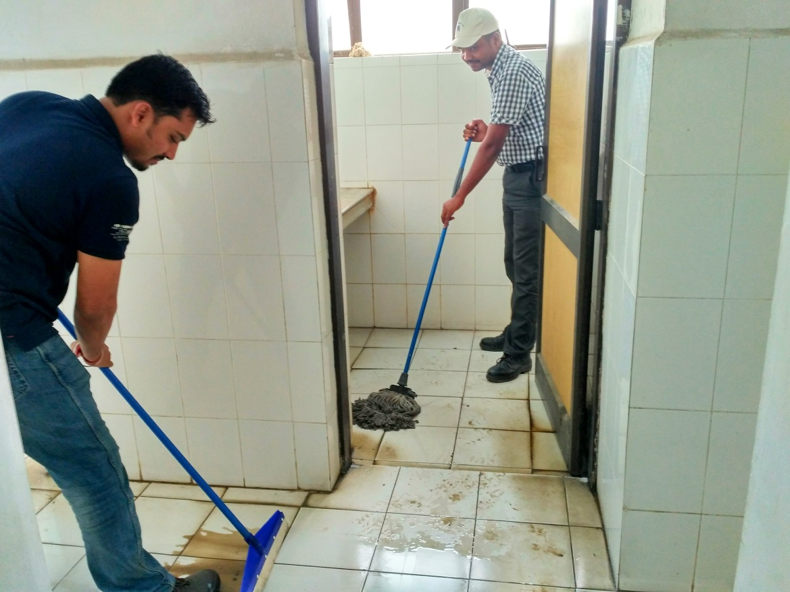

NRL_Cleanliness Drive in SMT,Siliguri at Control room outside on 26.07.2017

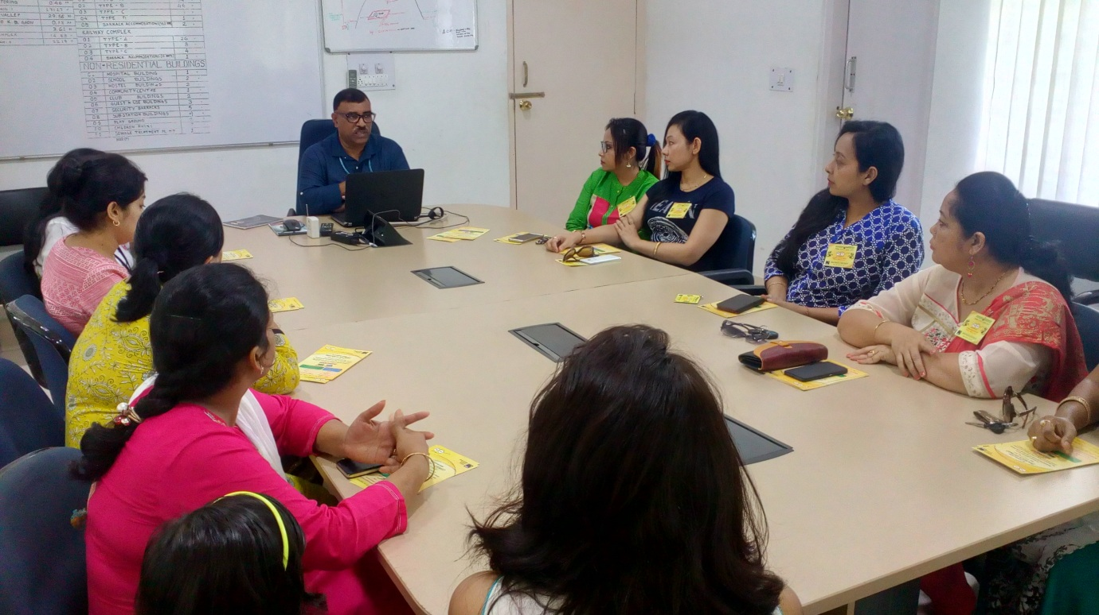

NRL_awareness drive in waste segregation_township_27.07.2017

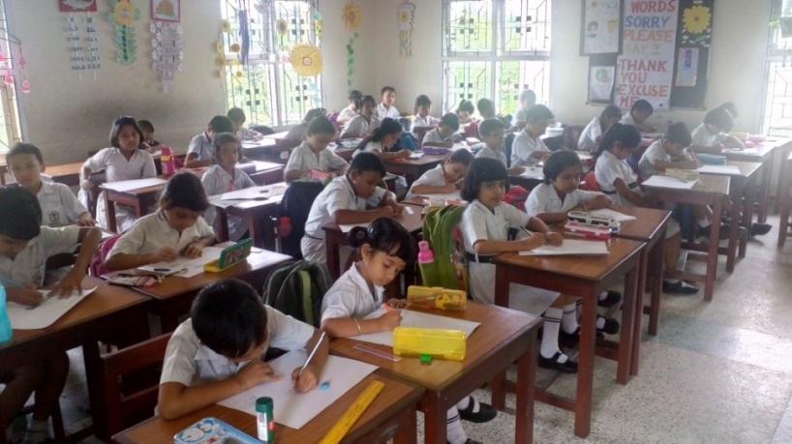

Drawing competition conducted in JR. DPS, NRL Township_ 27/07/2017

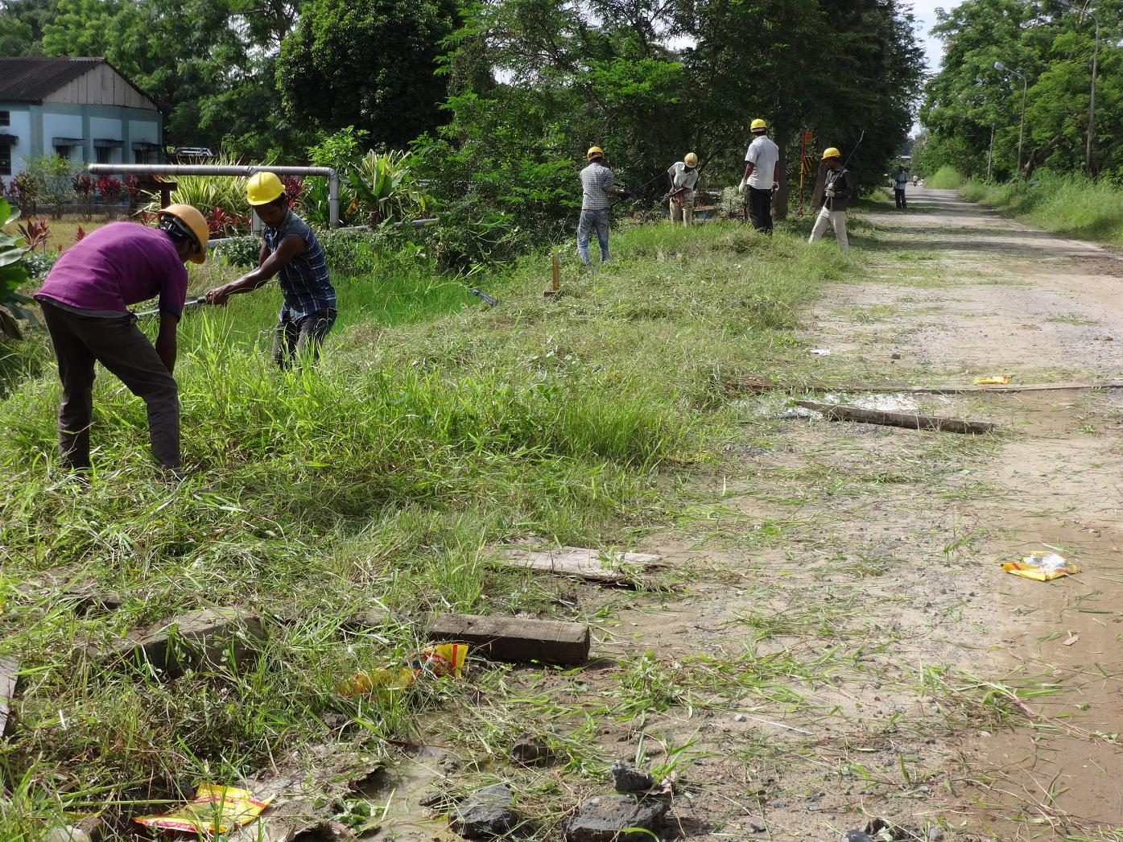

NRL_Cleanliness drive_near cooling tower area_28.07.2017

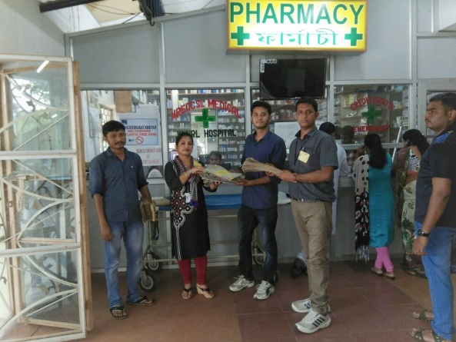

Awareness Drive in NRL Township on Plastic free movement_ 28/07/2017

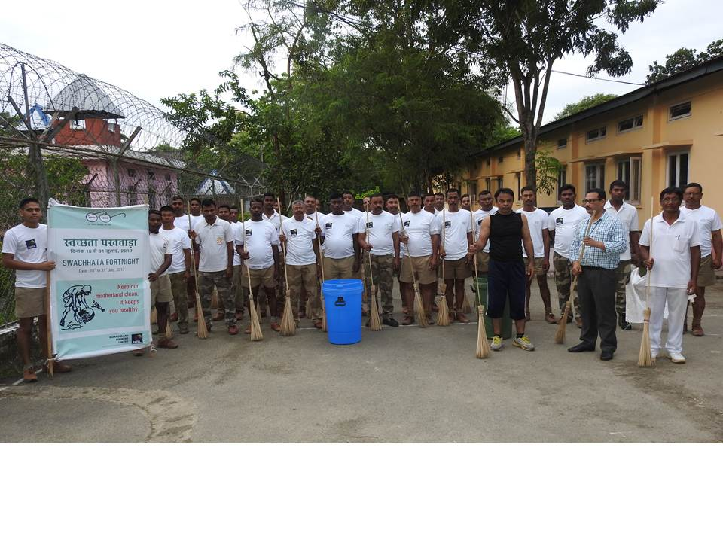

Cleanliness Drive in NRL CISF Colony_ 30/07/2017

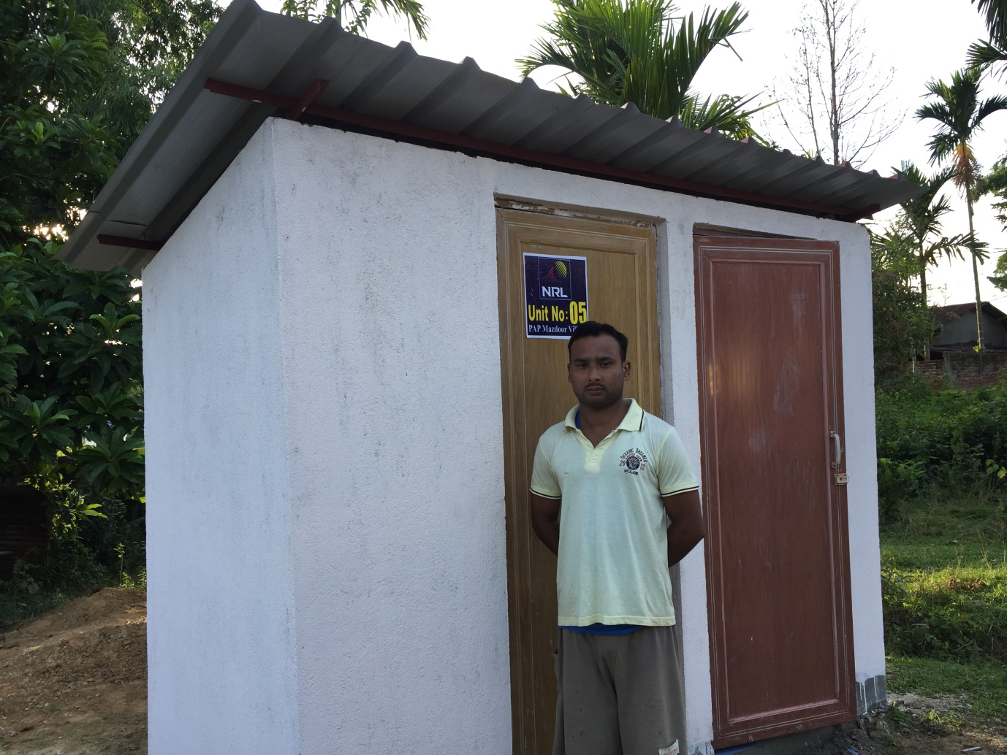

NRL_Toilet inauguration on 31.07.2017 in PAP Mazdoor village

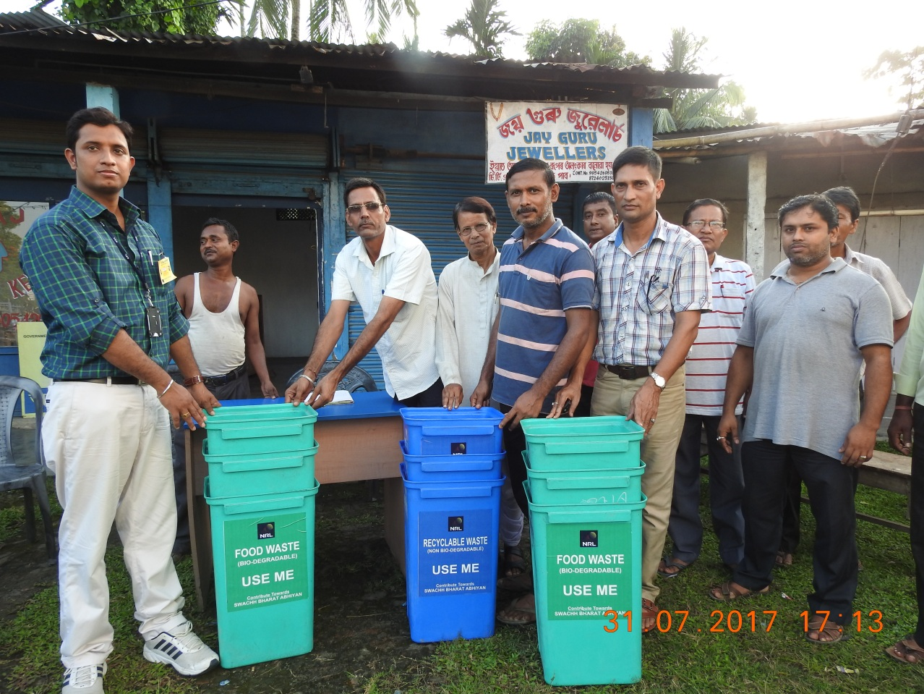

Installed Dustbin in Nearby Telgorom Market, NRL_31/07/2017