

ADMIN USER MANUAL

11 April, 2016

Created By: Planet E-Com Solutions Pvt. Ltd

Contents

1. How to do Login/Logout 3
2. How to Create an Admin 4
3. How to Assigning Rights to User 6
4. How to ADD/UPDATE Main Menu Heading 7
5. How to enter Content in Main Menu 9
6. How to Main Menu Data Approval/Decline 12
7. How to View Archive Menu Item 14
8. How to ADD Left Menu Heading 15
9. How to Add Left Menu Content 16
10. How to get Left Menu Data Approval/Decline 18
11. How to Add News 19
12. How to Approve News 20
13. How to Update News 23
14. How to Edit/Update News Comments 25
15. How to Add/Update Photo/Video Gallery 25
16. How to Add/Update Quick Links 27
17. How to Add /Approve other Link Content 28
18. How to Add /Update Contact Us 29
19. How to Approve/Decline Contact Us 30
20. How to Add/Update FAQ's 32
21. How to Audit Trail 33
22. How to see Feedback/Suggestion Details 35
23. How to view Error Log 36
24. How to add Feedback Questions 37
25. How to see User Visits 38
26. How to enter tender 38
27. How to approve/decline Tender 39
28. How to add Addendum / Corrigendum 41
29. How to Edit Tender 42
30. How to edit Tender Master 43

How to do Login/Logout

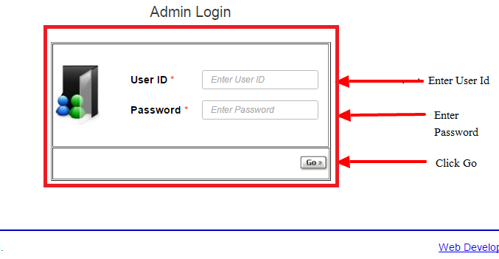
- Login NRL with valid Credentials.

- Click on Logout on right corner to Logout.

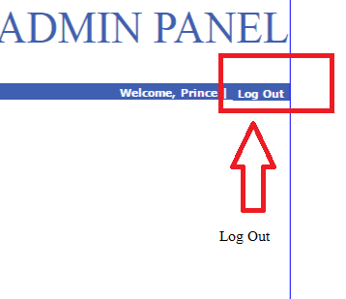

How to Create an Admin

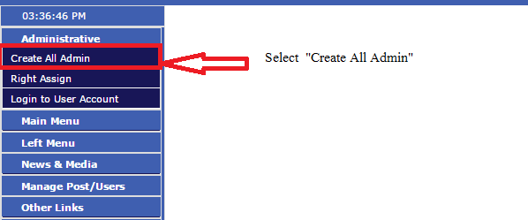
a) Select “Create All Admin” from “Administrative” drop down.

b) Select Admin Type you want to create.
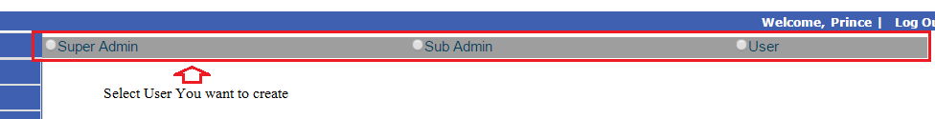
c) Select Admin type from drop down.

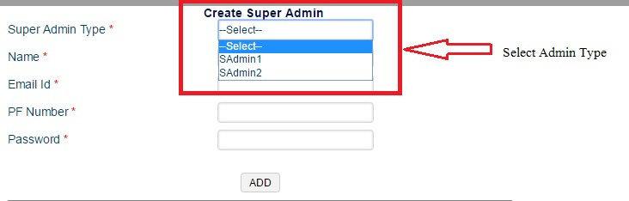

d) Fill complete detail in new user form.
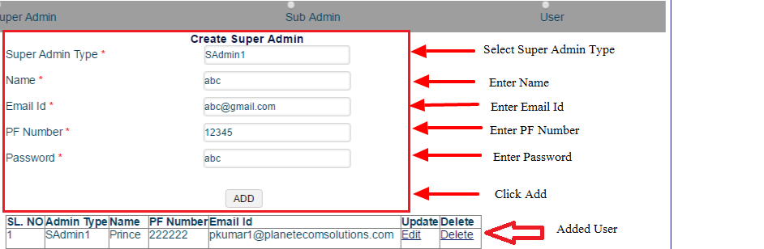

How to Assigning Rights to User

a) Select Admin and user name from Assigning right to User.

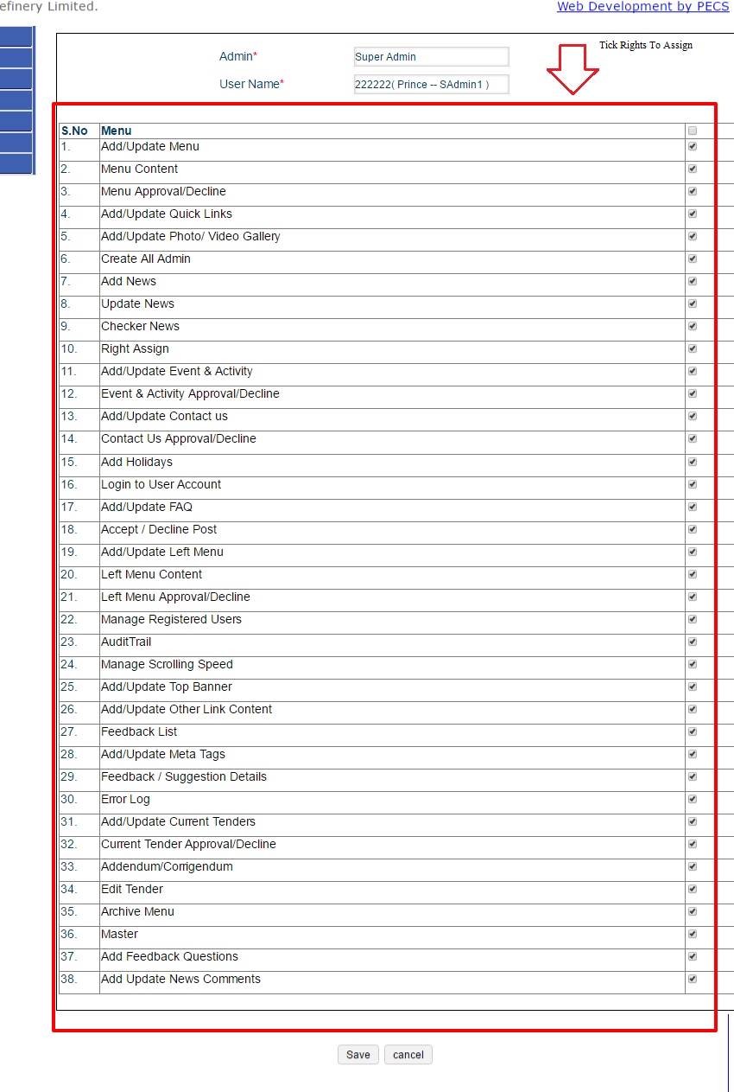
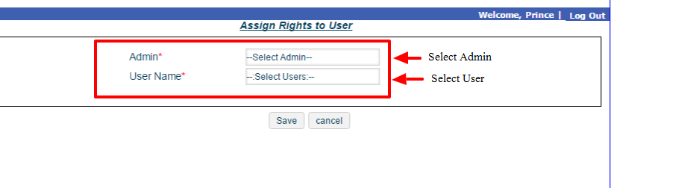
b) Select right you want to assign to user.

How to ADD/UPDATE Main Menu Heading

a) Go to ADD/UPDATE Menu.
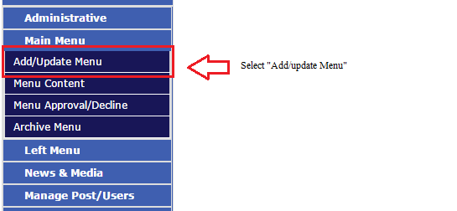

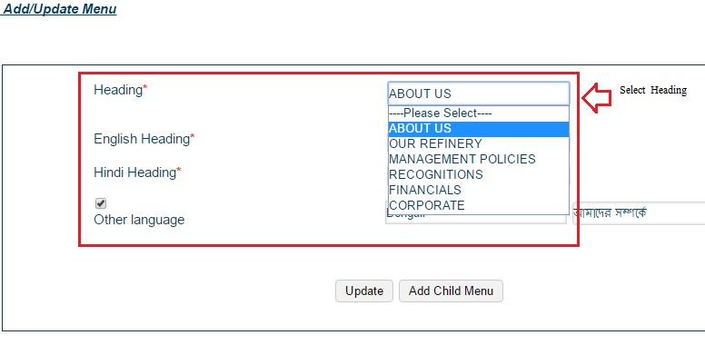
b) Select heading to update.
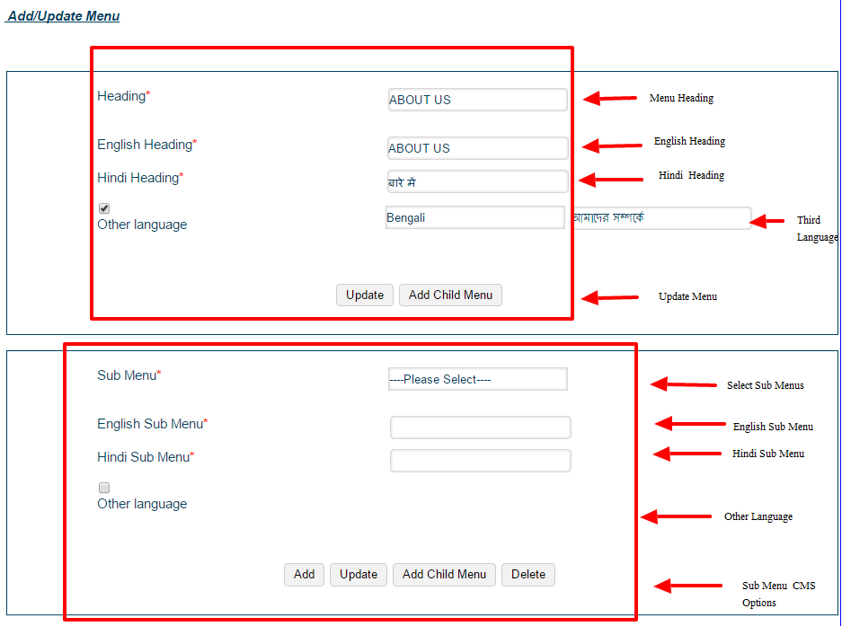
c) Enter Menu Submenu you want to enter in both Hindi and English.

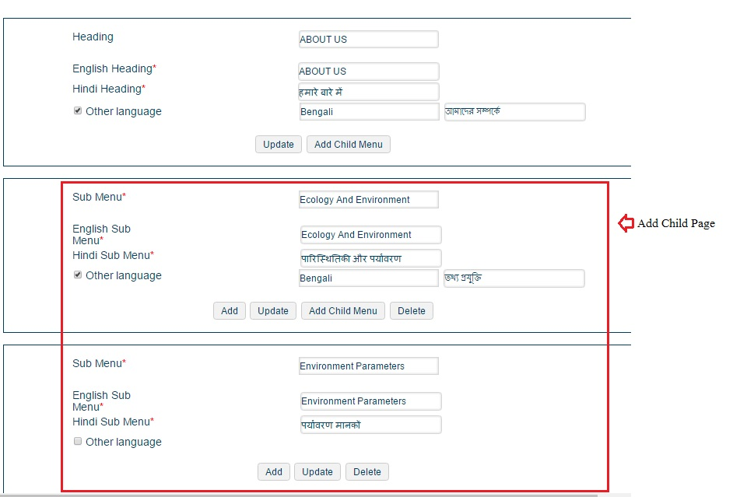
d) Add Child Page if you require.

How to enter Content in Main Menu

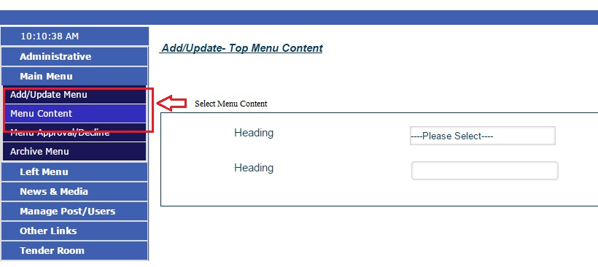
a) Go to Menu Content in Main Menu drop down.
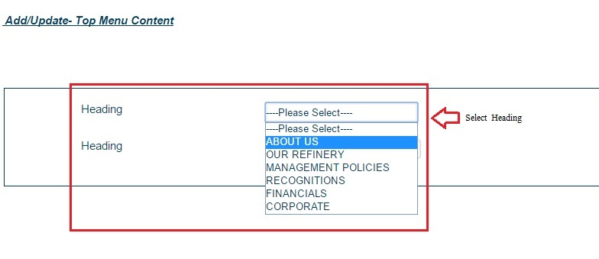

b) Select Heading you want to update content.
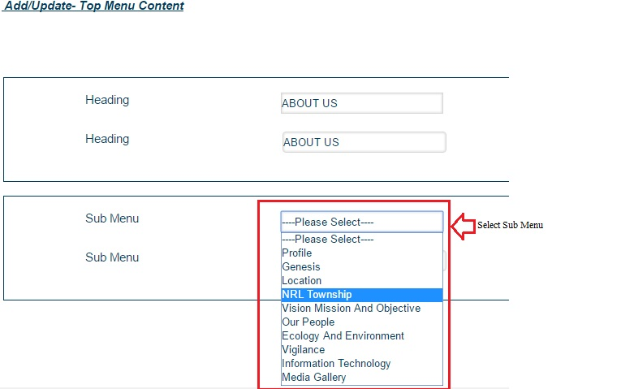
c) Select sub menu in which you want to enter content.

d) Enter Data in the field and along with valid and archive date.
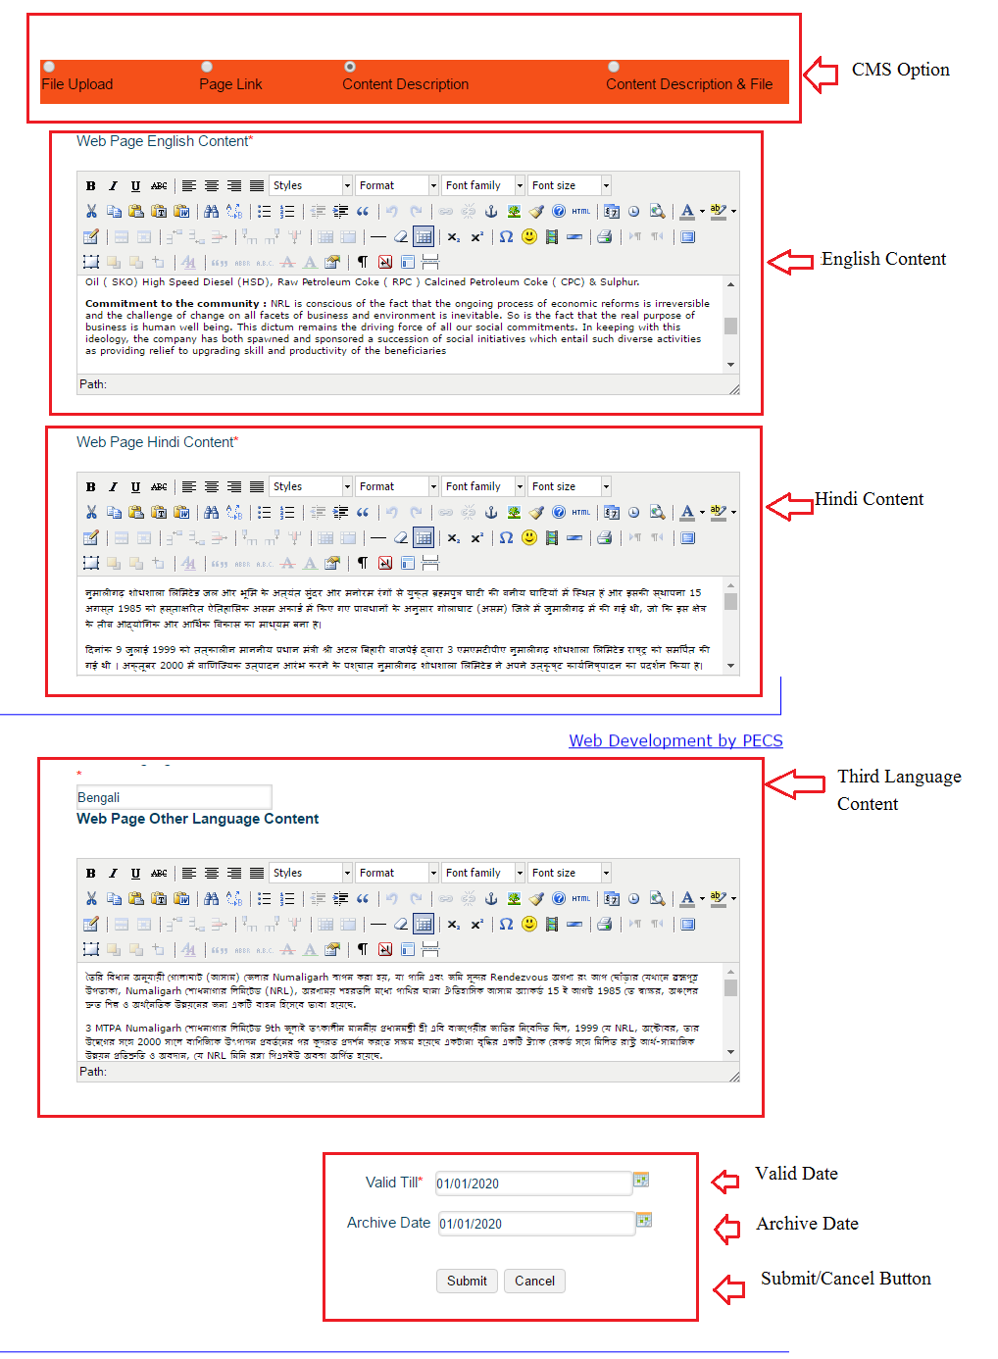

How to Main Menu Data Approval/Decline

a) Select Menu Approval/Decline from Main Menu.

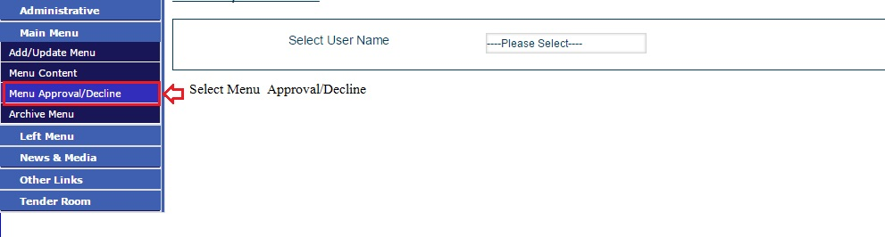
b) Select User Name from drop down in Website Updation Detail Page.
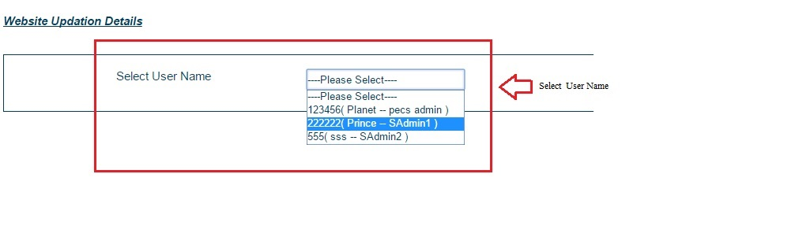

c) Select View option from user list to Approve /Decline Content.
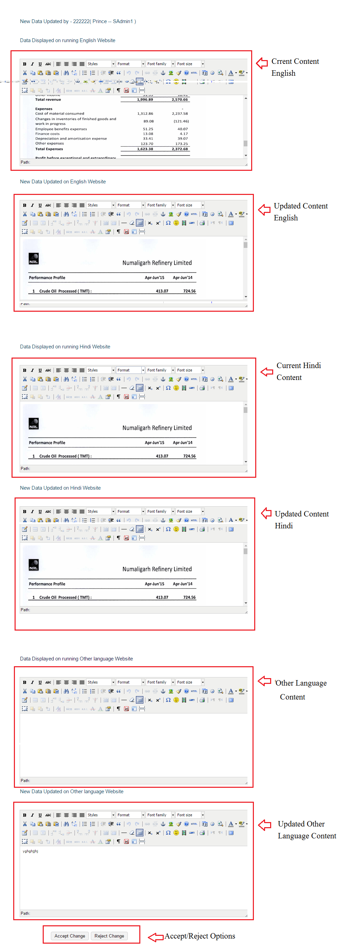

How to View Archive Menu Item

a) Go to archive menu on Main Menu list.
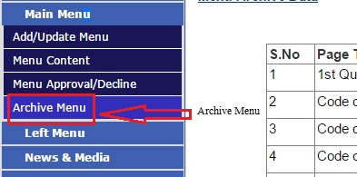

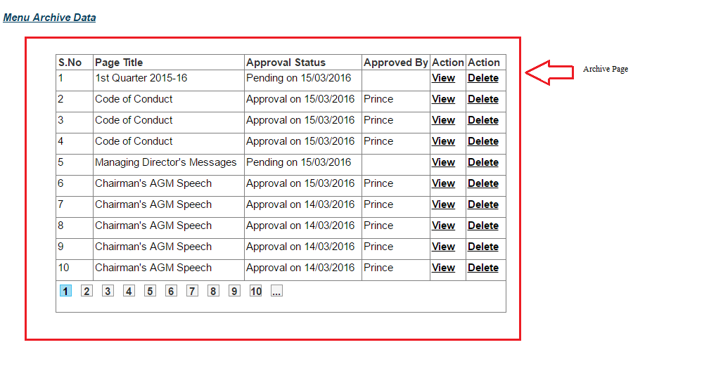
b) Select view from archive page list to view archive page.

How to ADD Left Menu Heading

a) Select Add/Update Left Menu from Left Menu List.
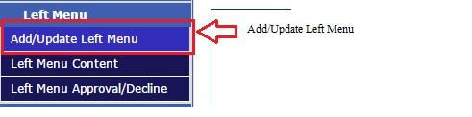

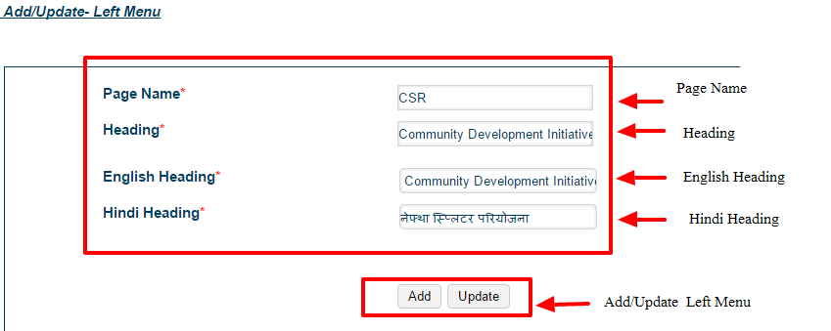
b) Fill Add/Update Left Menu Form and press Add to add new menu item.

How to Add Left Menu Content

- Go to Add Left Menu Content.
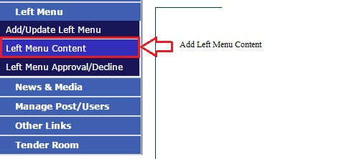
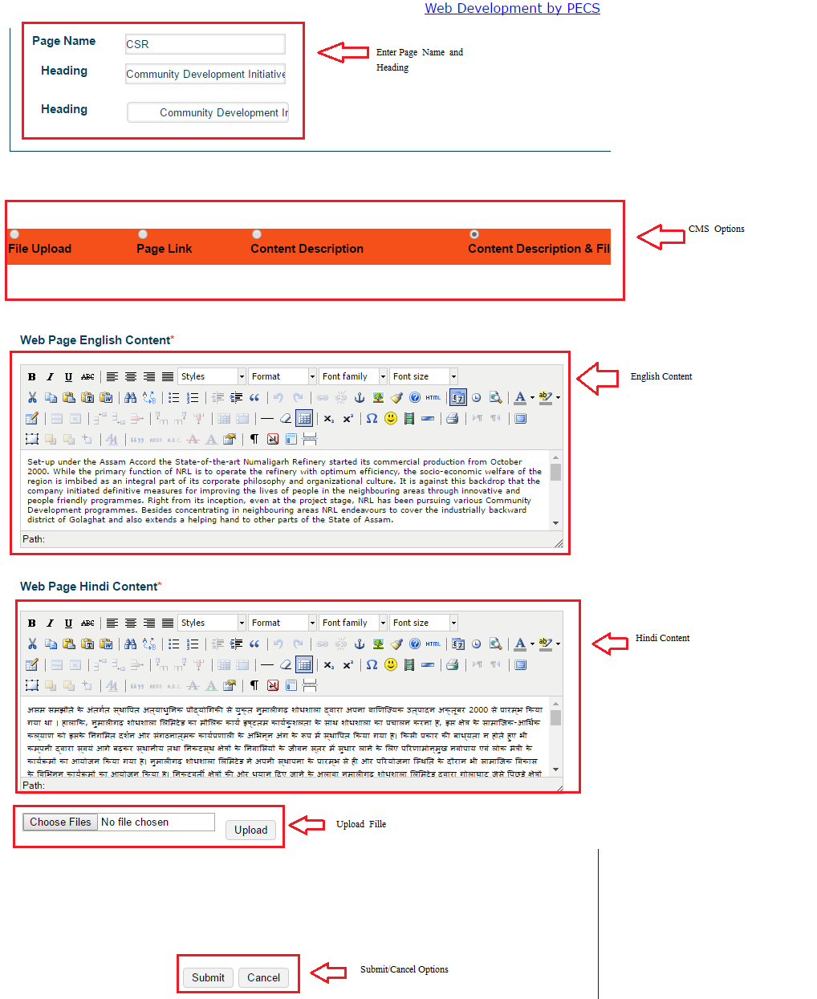
b) Fill Content in form to update.

How to get Left Menu Data Approval/Decline

a) Go to left menu Approval /Decline.

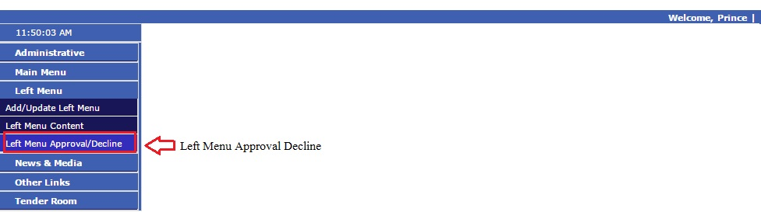

- Select User to see Menu Items List entered by him.

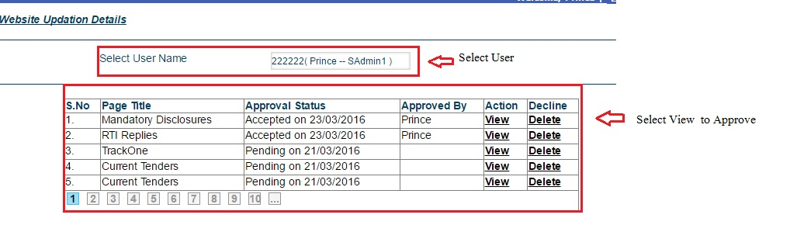
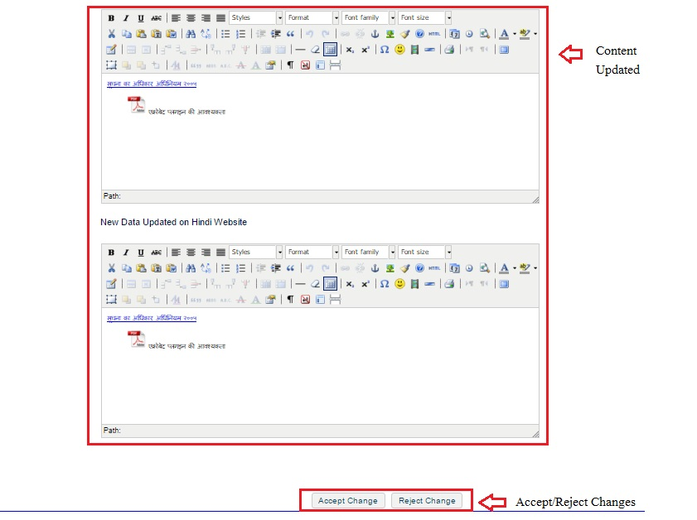
c) Go through Data entered and then approve.

How to Add News

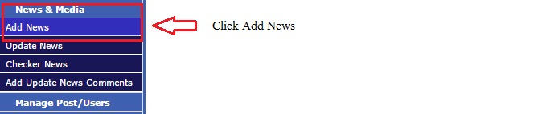
- Go to Add News.

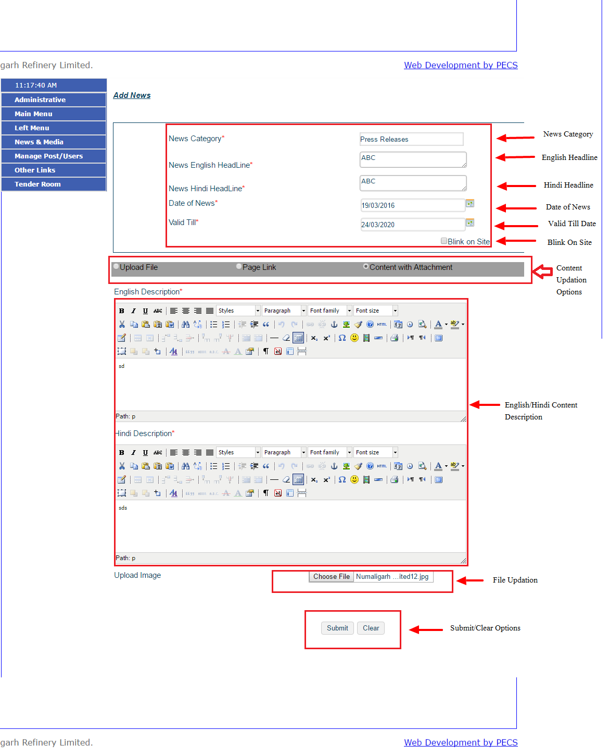
- Fill Details of form, write content and attach file on requirement.

How to Approve News

- Go to Checker news.

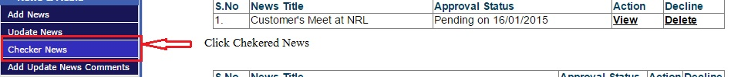

- Select news status.

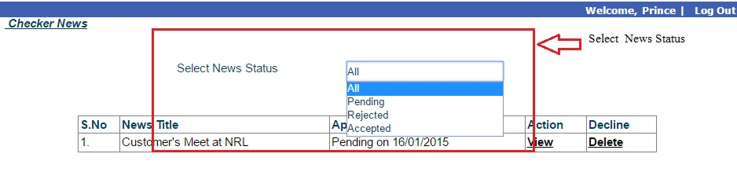
- Select View Option to Approve.

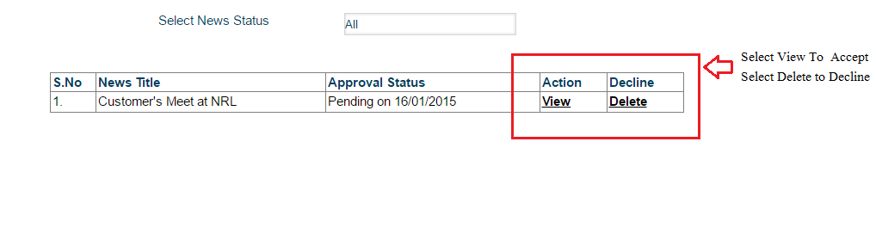
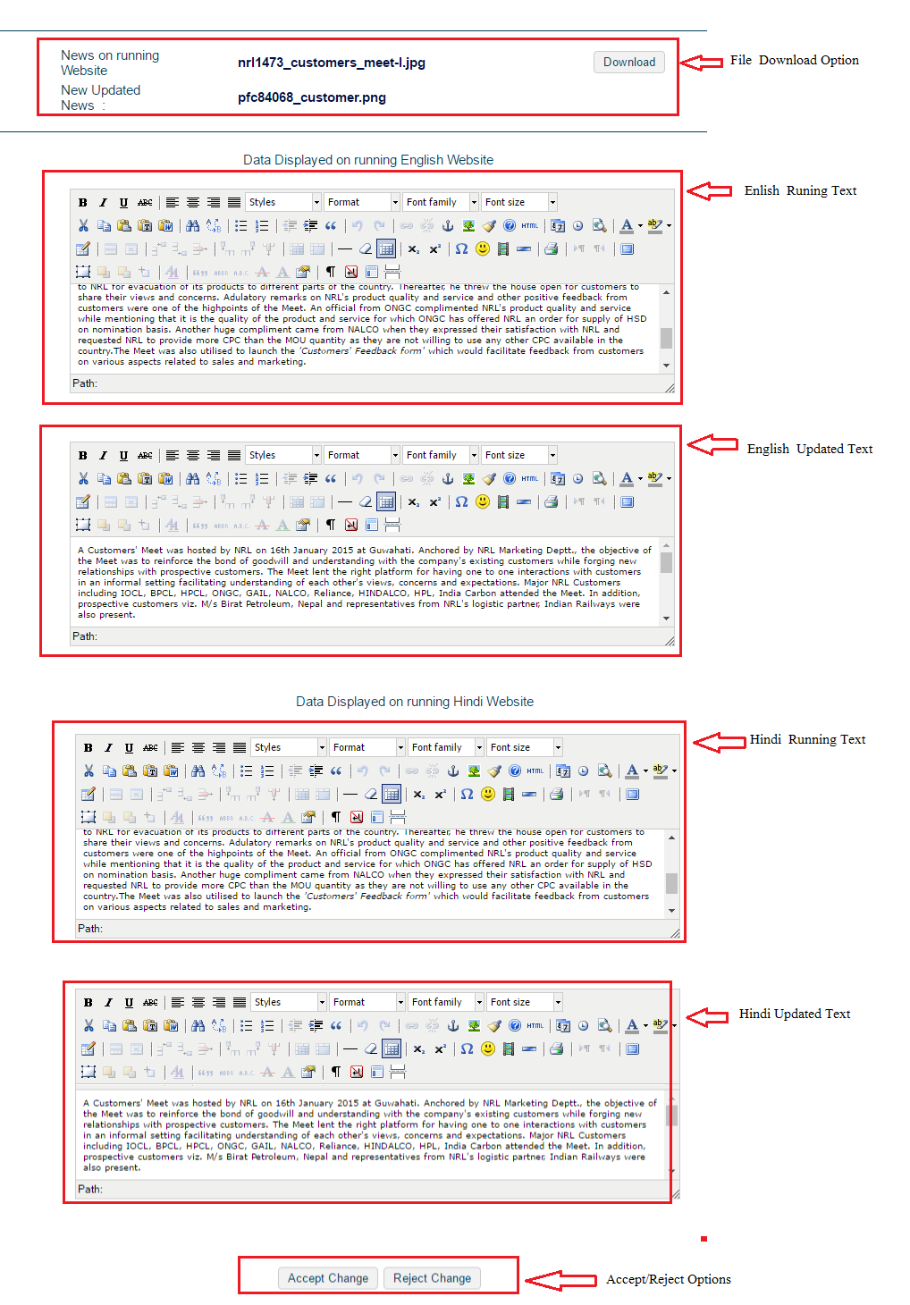
- Look into the news changes than Approve/Decline as per requirement.

How to Update News

a) Select Update News from News & Media.

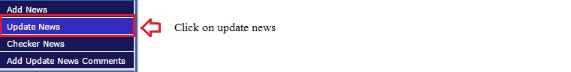

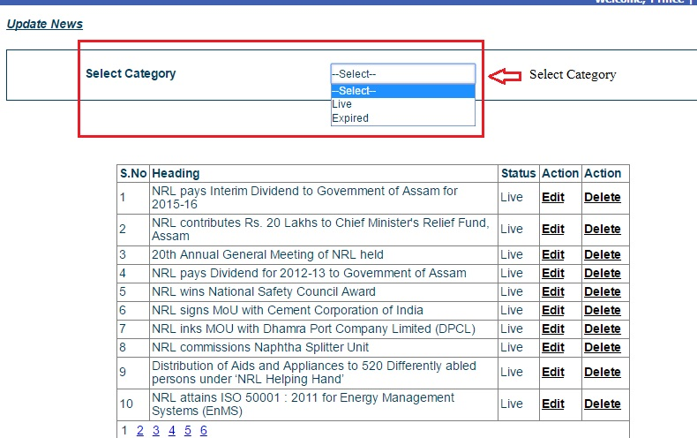
b) Select News Category.
c) Select edit option to approve.

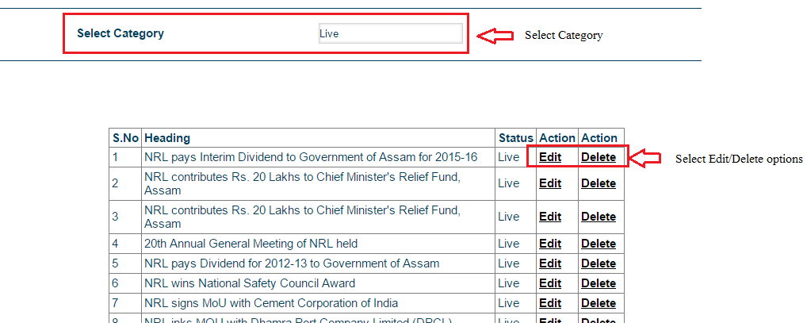
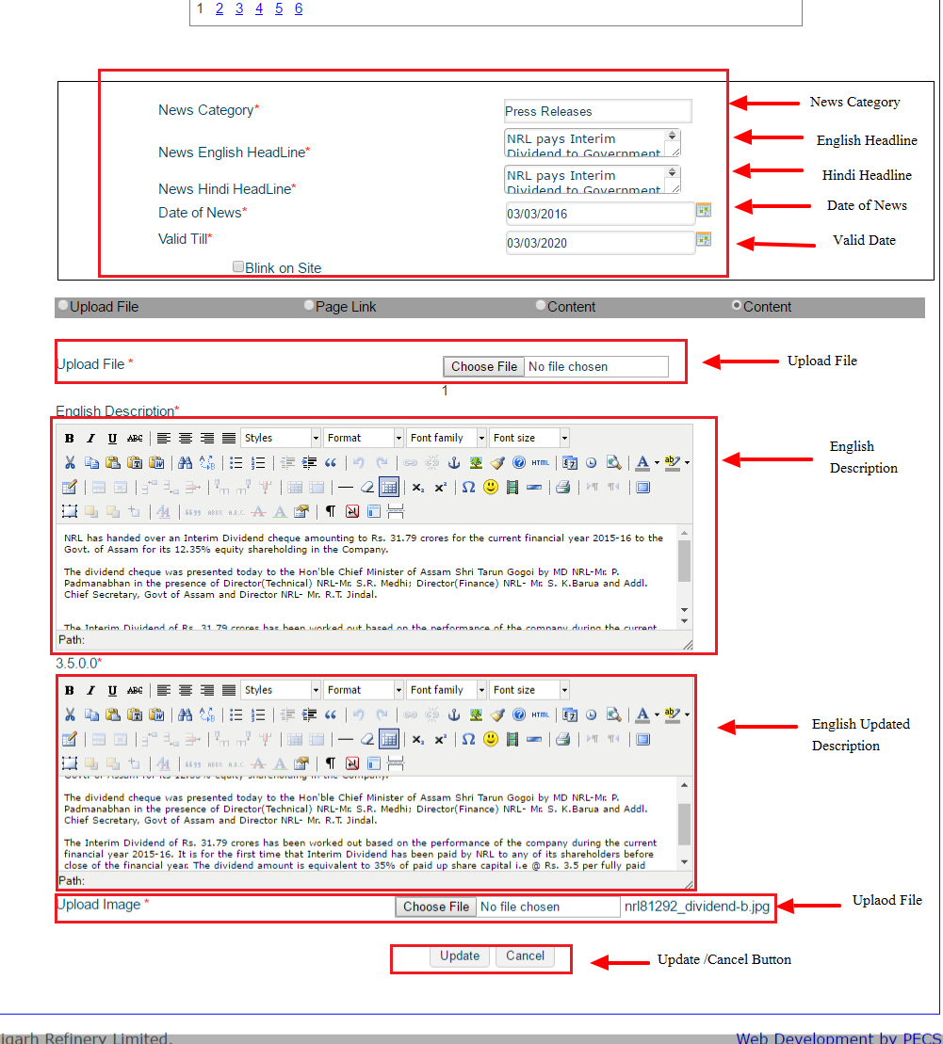
d) Look through form and Accept/Cancel Changes.

How to Edit/Update News Comments

a) Go to Edit/Update News Comments.

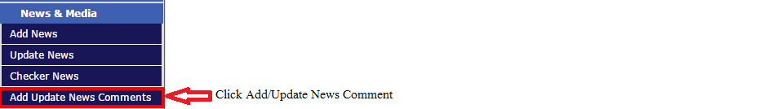
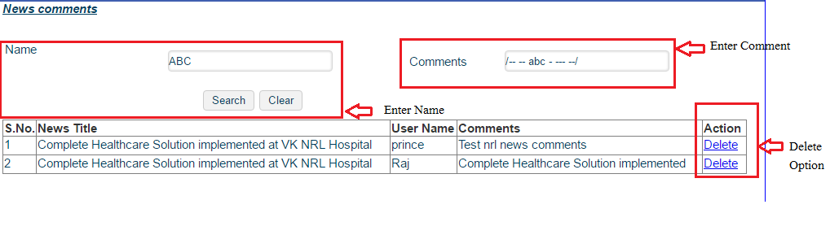
b) Select Name, Comment and do appropriate action.

How to Add/Update Photo/Video Gallery

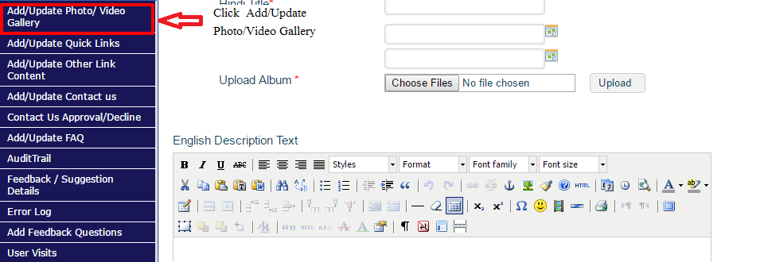
a) Go to Add /Update Photo/Video Gallery under Other Links.

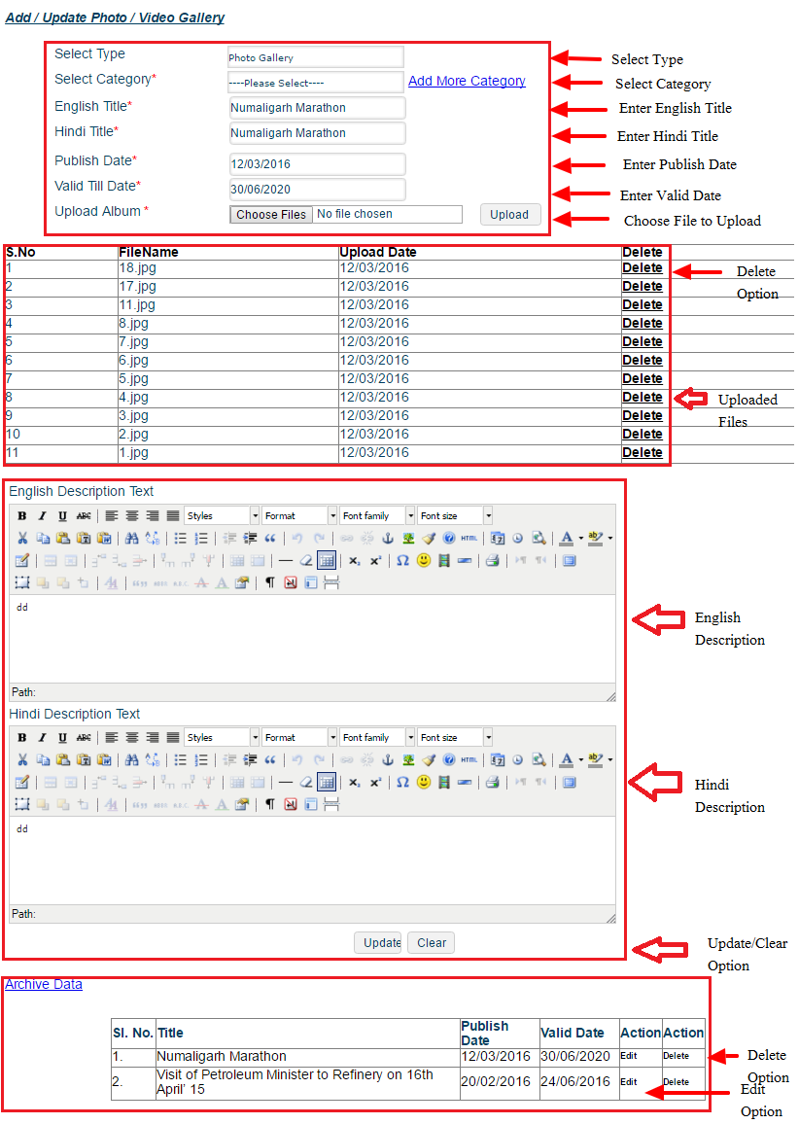
b) Fill required details and attach file accordingly then approve or reject.

How to Add/Update Quick Links

a) Go to Add/Update quick Links.

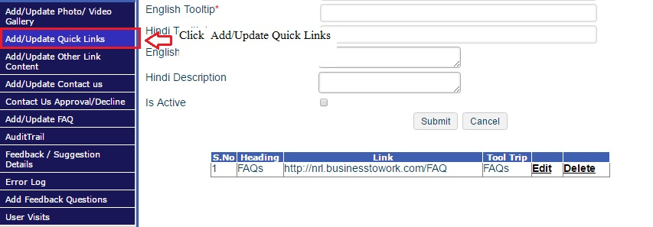
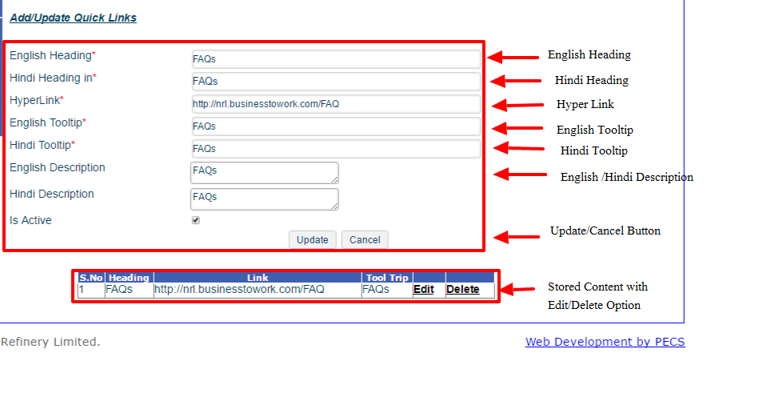
b) Fill the opening form accordingly before approval or decline.

How to Add /Approve other Link Content

a) Go to add/approve other link Content.
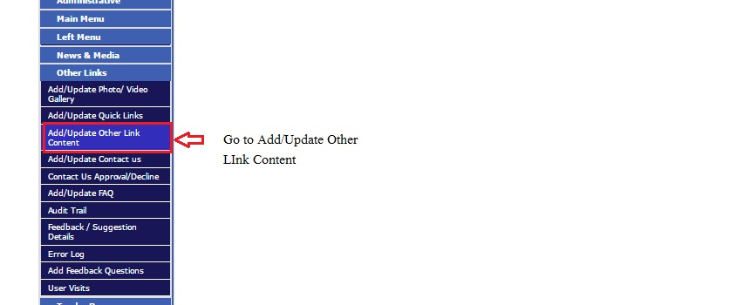

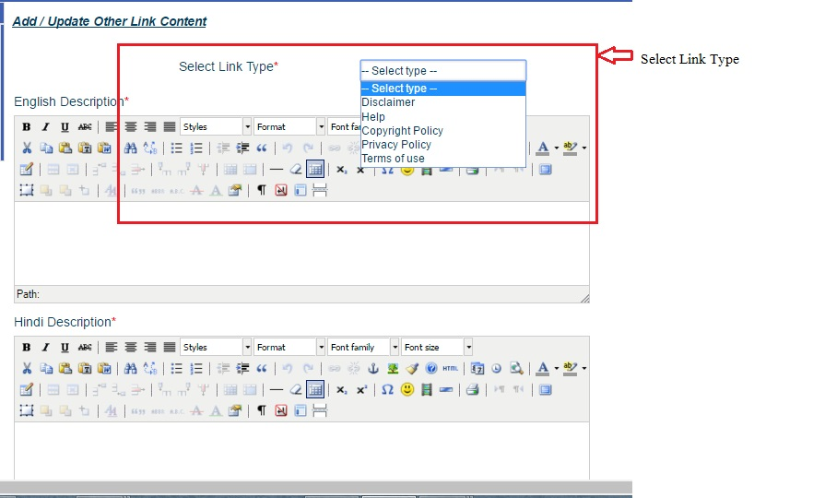
b) Select Link Type from drop down.
c) Add or Update content and then press Update or Cancel accordingly.

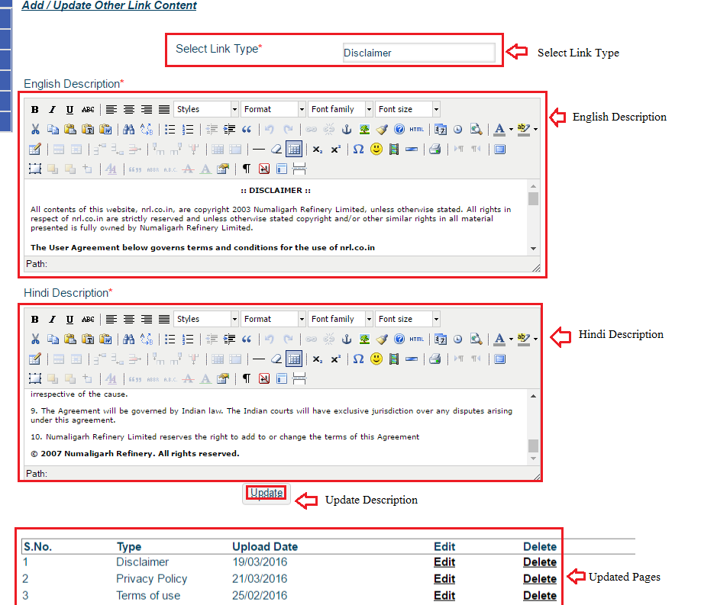

How to Add /Update Contact Us

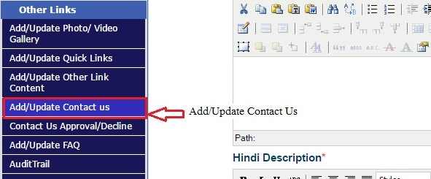
a) Go to Add/Update Contact Us.

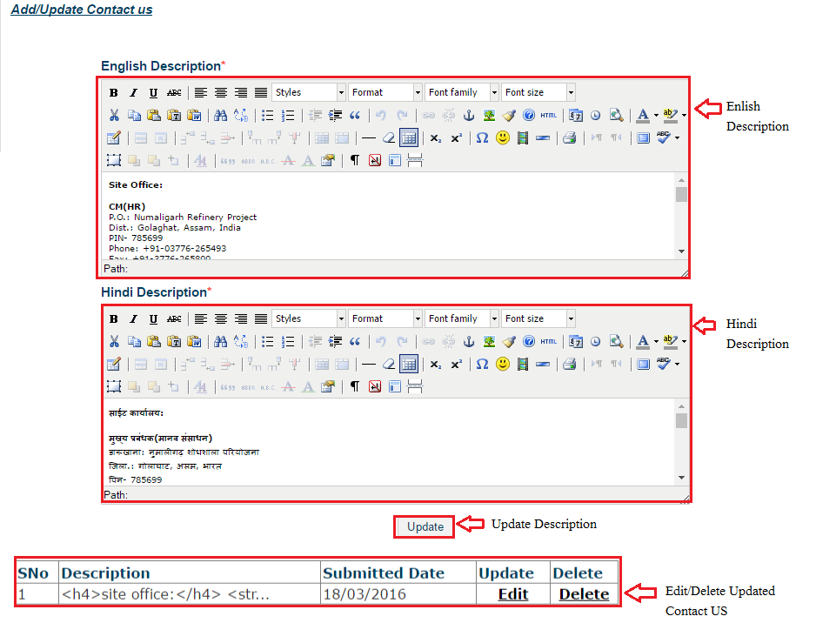
b) Update Data in Field and then place update.

How to Approve/Decline Contact Us

- Go to Approve/Decline Contact Us.
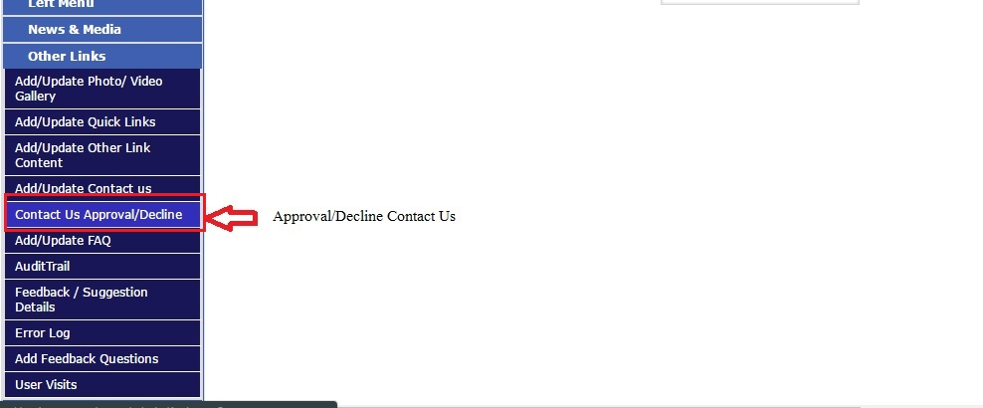

- Select Contact Us Status and select view to see content.

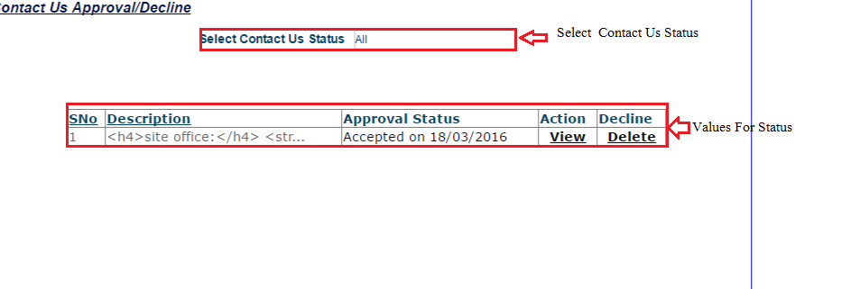

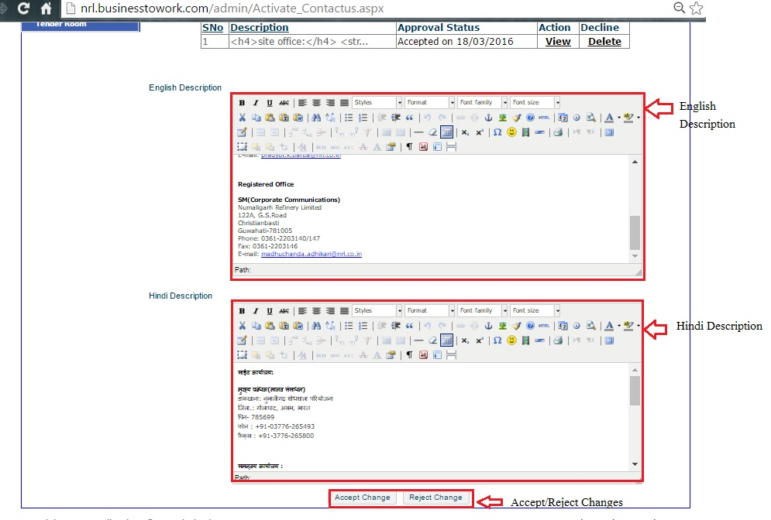
- Look through content and press Accept/Reject button.

How to Add/Update FAQ's

- Go to Add/Update FAQ's.

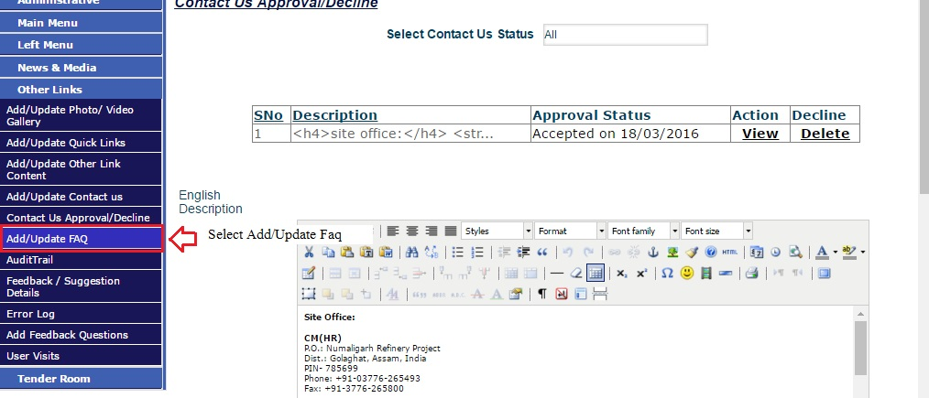

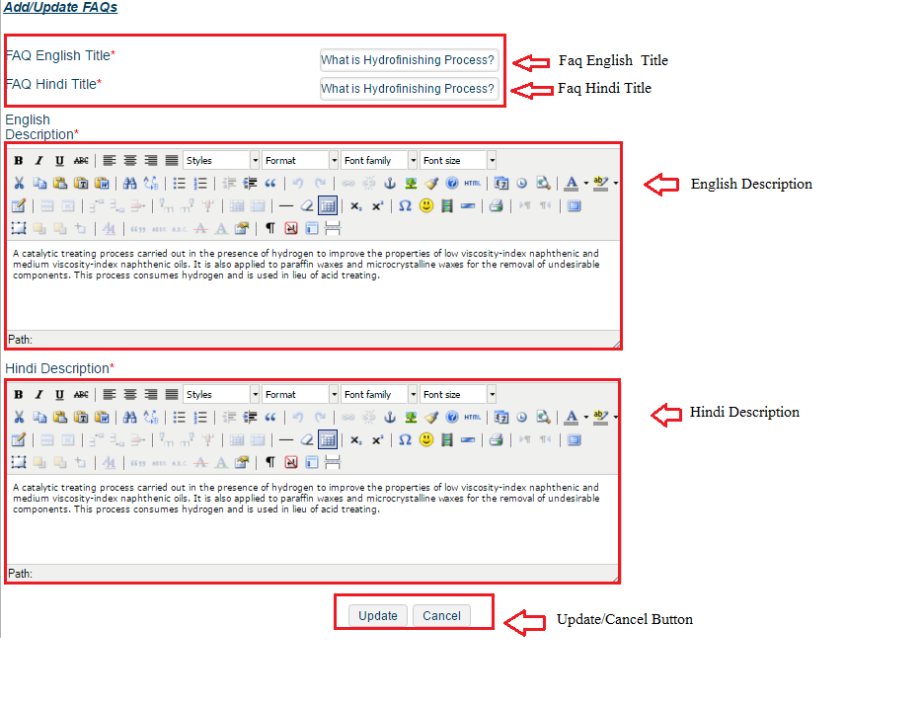
- Enter FAQ Title and Data before pressing Update or Cancel.

How to Audit Trail

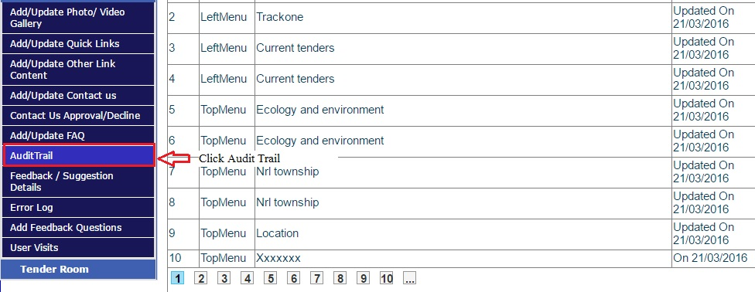
a) Go to Audit Trail.
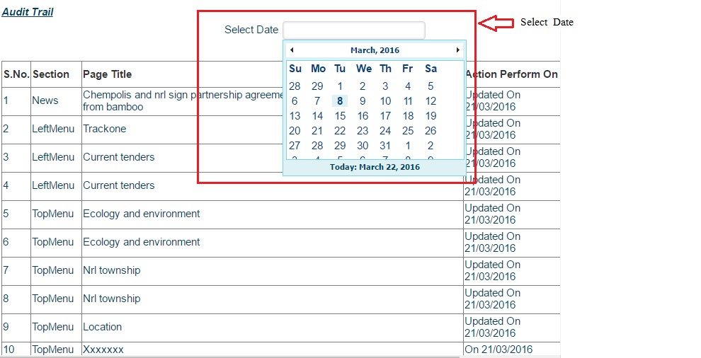
b) Select date from date picker.

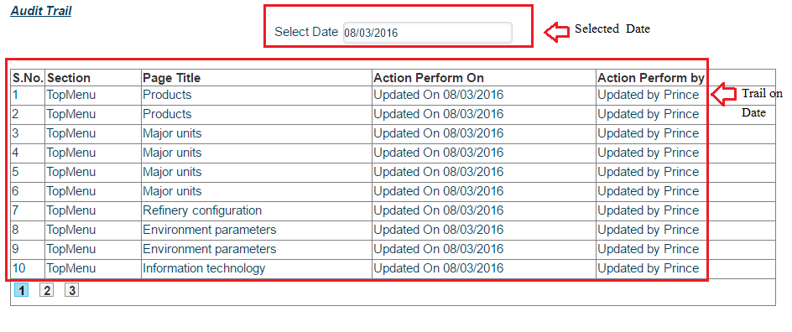
- After selecting Date trail on date list appear.

How to see Feedback/Suggestion Details

- Go to Feedback/Suggestion Detail.
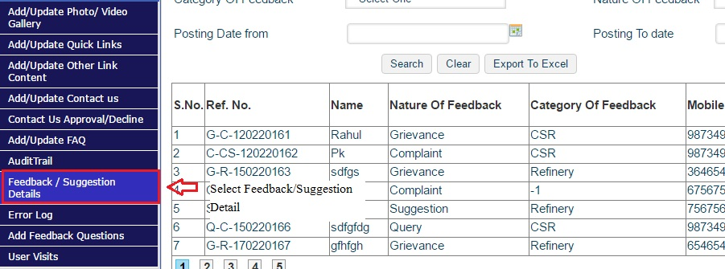

- Enter Details of feedback in below fields to see Corresponding feedbacks.
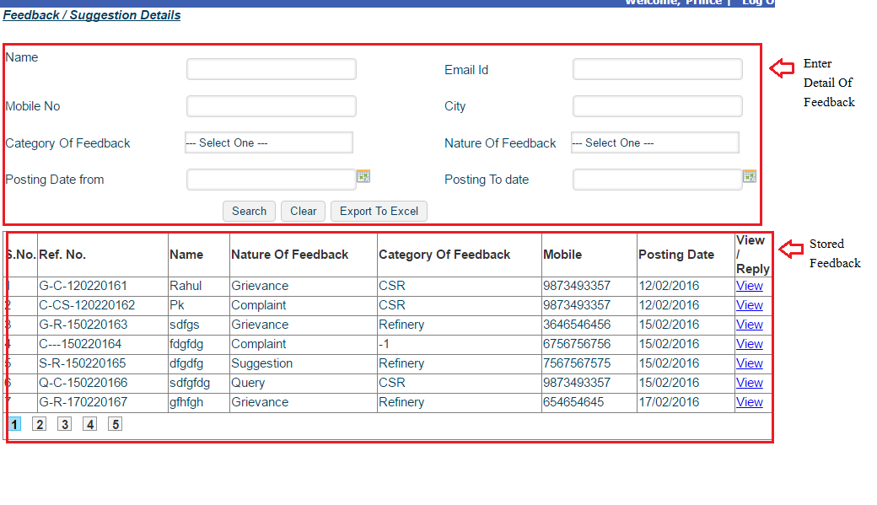

How to view Error Log

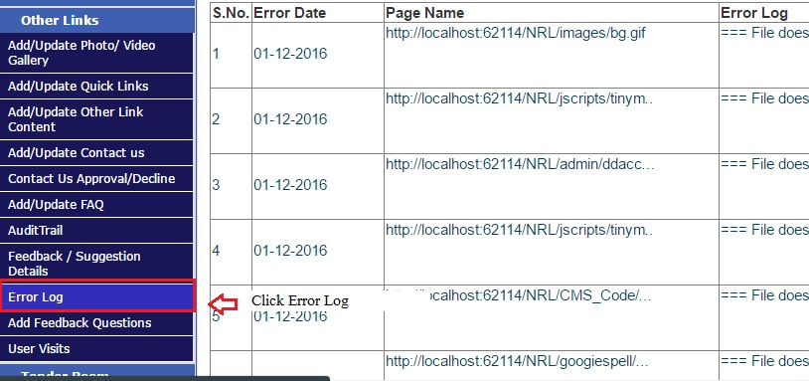
a) Go to Error Log in Other Links.

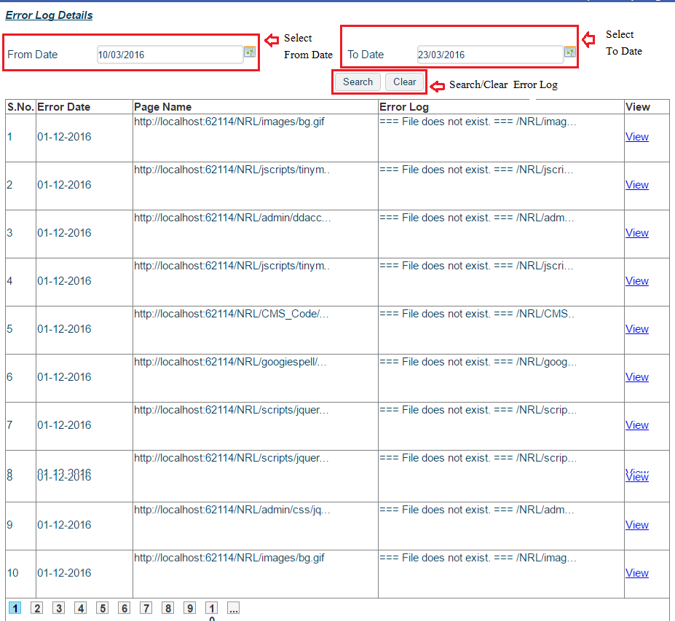
b) Enter From date and To date to see error b/w these date.

How to add Feedback Questions

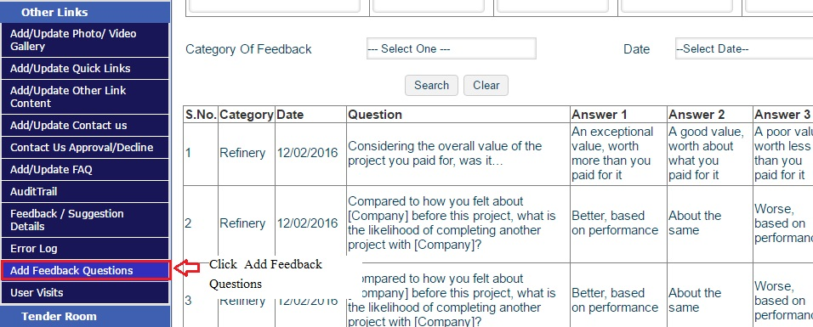
a) Go to Add Feedback Questions.

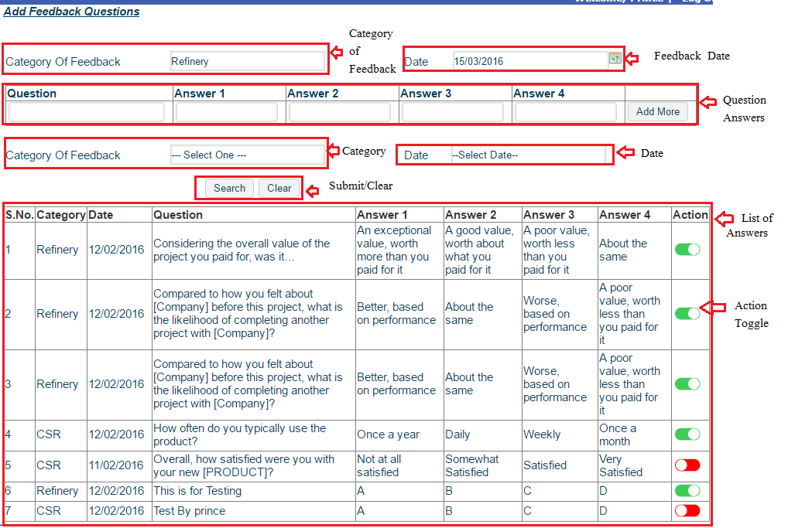
b) Fill Question detail in fields to search where you can decide to make it visible or in visible on site by toggling action button.

How to see User Visits

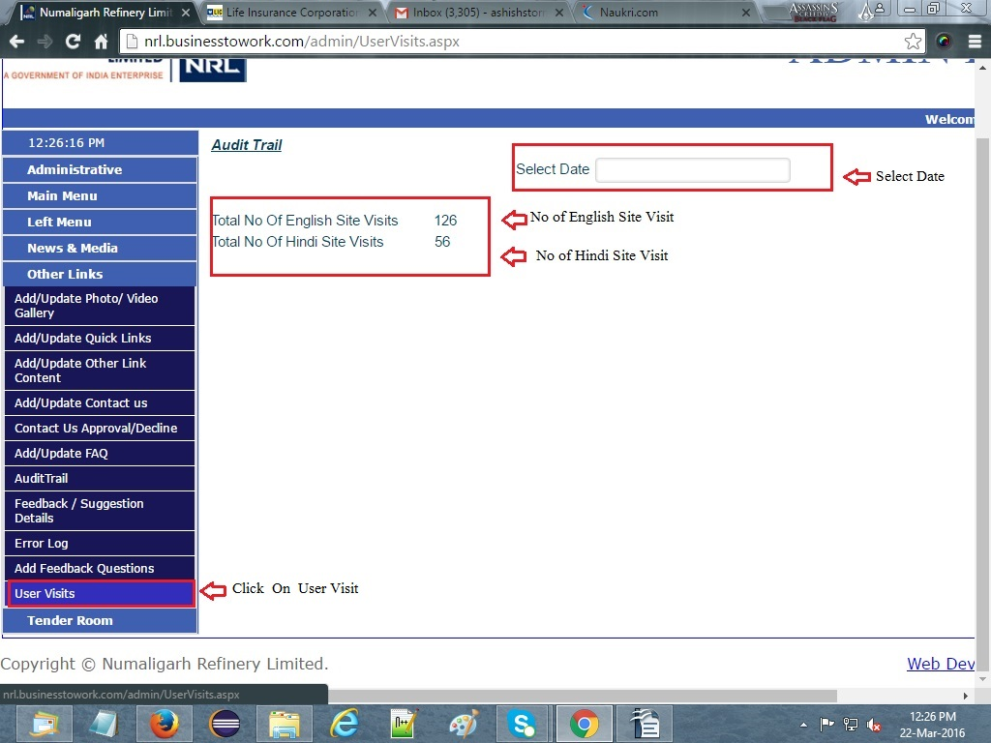
- Go to User visit under other links.

How to enter tender

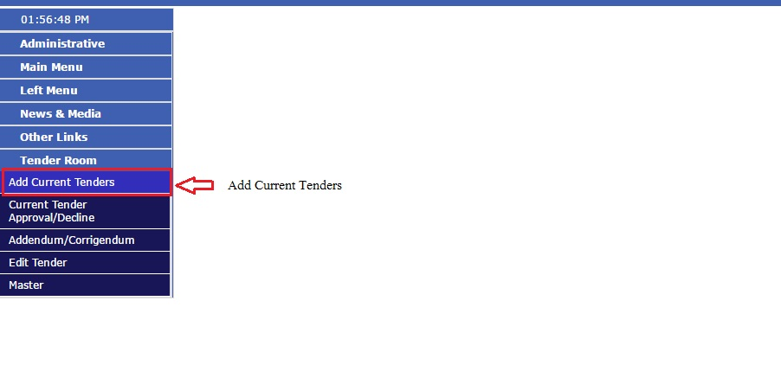
- Go to Add Current Tender in Tender Room.

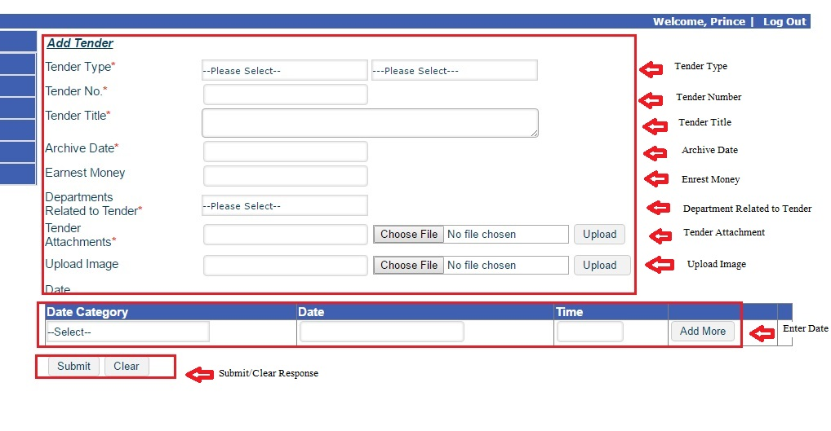b) Fill Tender form Details and press submit.

How to approve/decline Tender

- Go to Tender Approval/Decline.

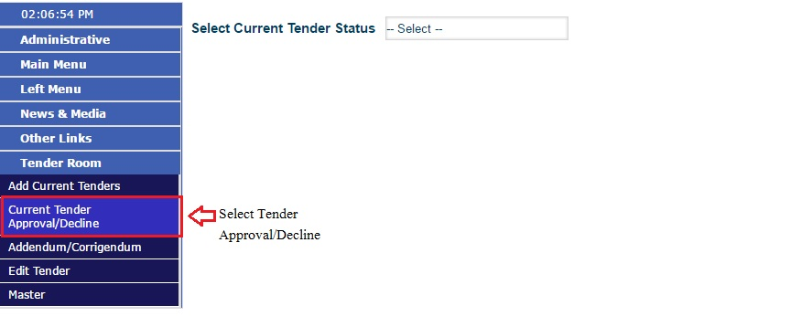

- Select Tender Status you want to open.
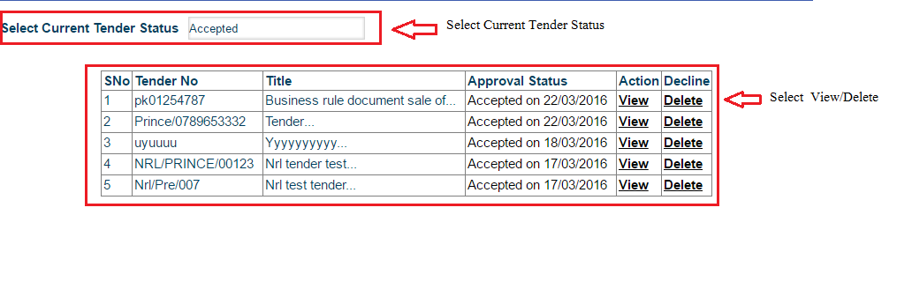

- Click view to see tender and press approve or reject button after seeing changes.

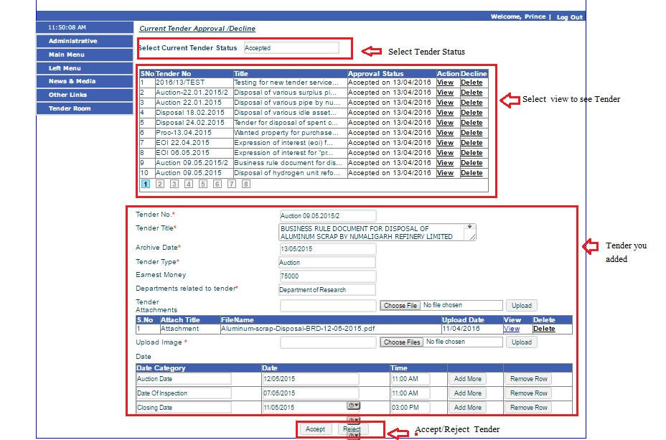

How to add Addendum / Corrigendum

- Go to Addendum/Corrigendum.
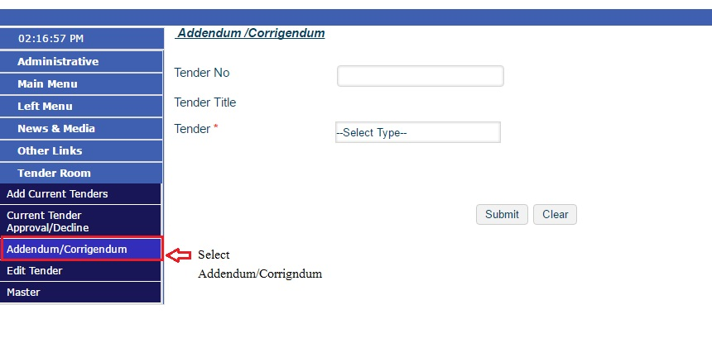

- Fill details of Addendum/Corrigendum in below fields and press submit.

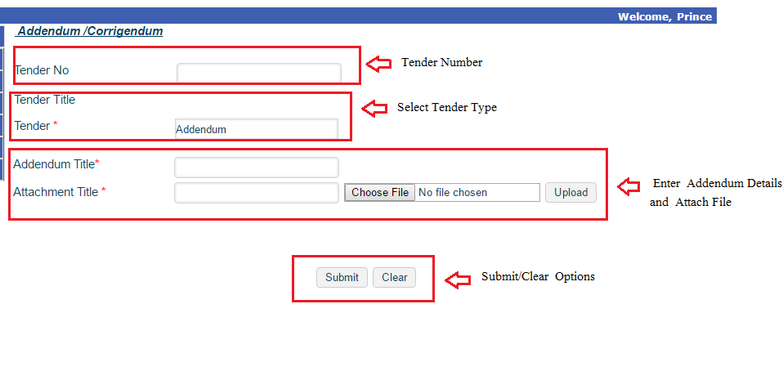

How to Edit Tender
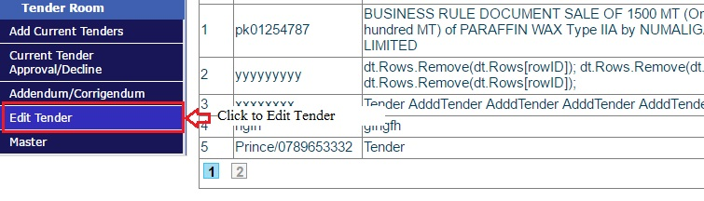
a) Go to Edit Tender.

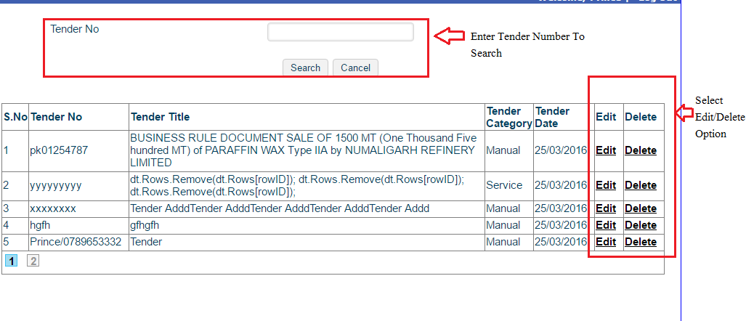
b) Enter Tender Number and select edit/delete action as per requirement.
c) Exit tender details and then press submit or clear as per requirement.
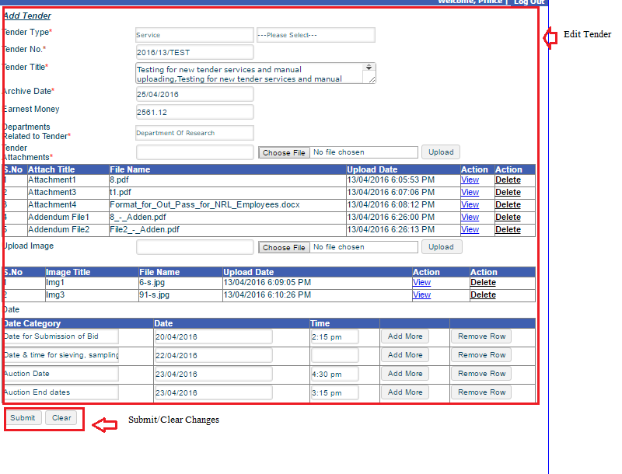

How to edit Tender Master

a) Go to master under Tender Room.
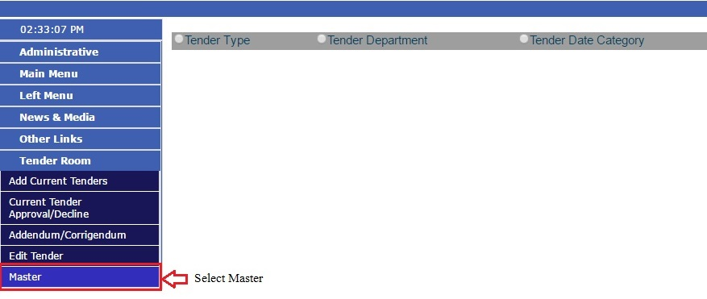

- Select Tender Category.

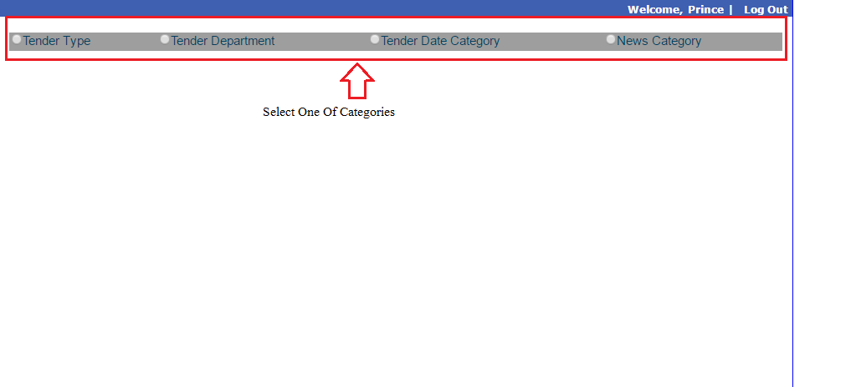
c) Select Action you want to proceed.
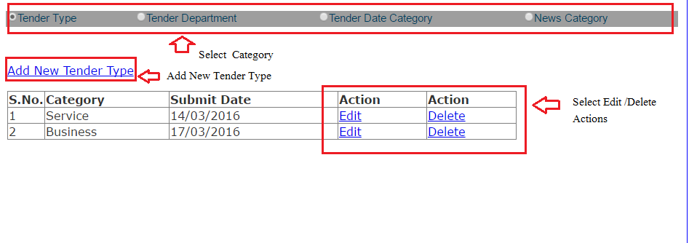

d) Enter Category Name you want to enter.

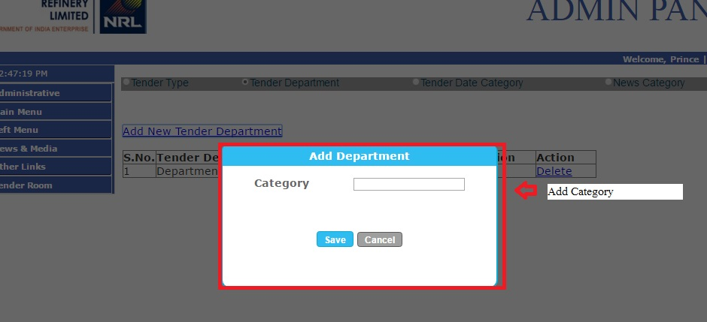

e) On selecting edit you can enter presently added category.

