ACTIVITIES CARRIED OUT IN NUMALIGARH REFINERY LIMITED ON THE OCCASION OF SWACHH BHARAT PAKHWADA FROM 16TH TO 31stJULY, 2017
Name of CPSE : NUMALIGARH REFINERY LIMITED
Name of administrative Ministry: MOPN&G
Date | Sl No | Activities carried out | Implementation status & photographs | Comments if any
24/07/2017 | 1 | Awareness drive at NRL Canteen on waste segregation & plastic free drive | 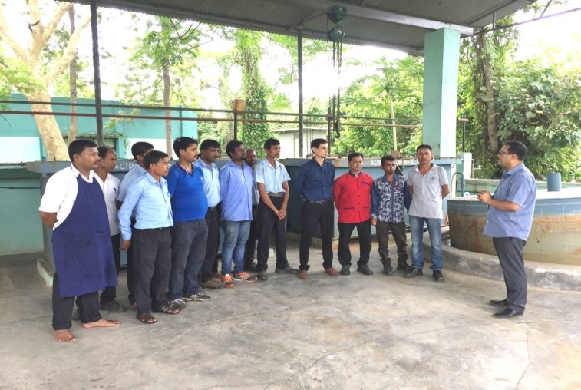 | Awareness Campaign in office
24/07/2017 | 2 | Awareness drive at Behora Market on waste segregation. | 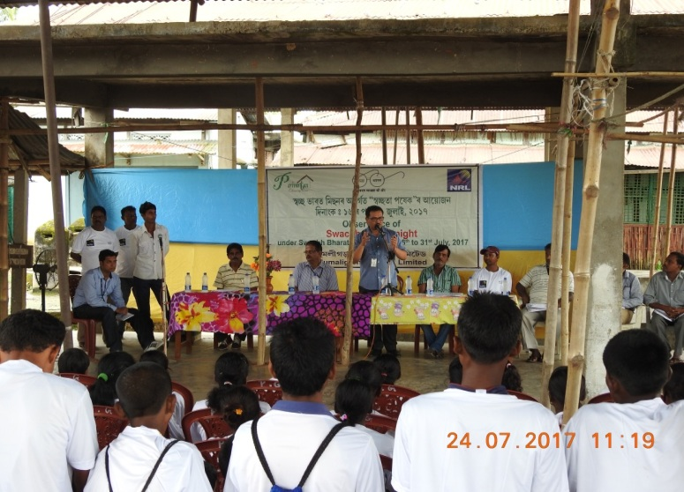 | Awareness Campaign in schools/ locality

24/07/2017 | 3 | Cleanliness Drive in Behora Market place. | 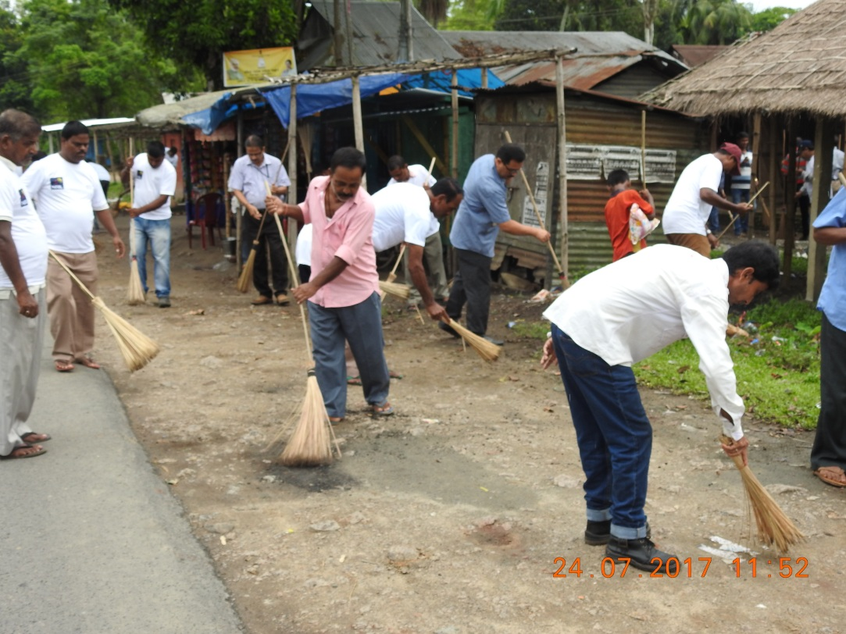  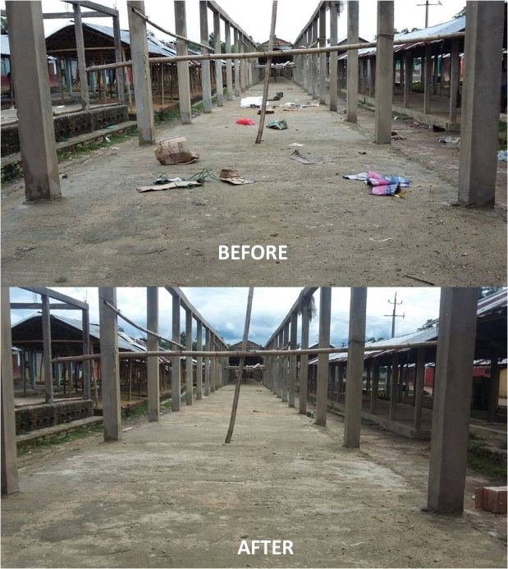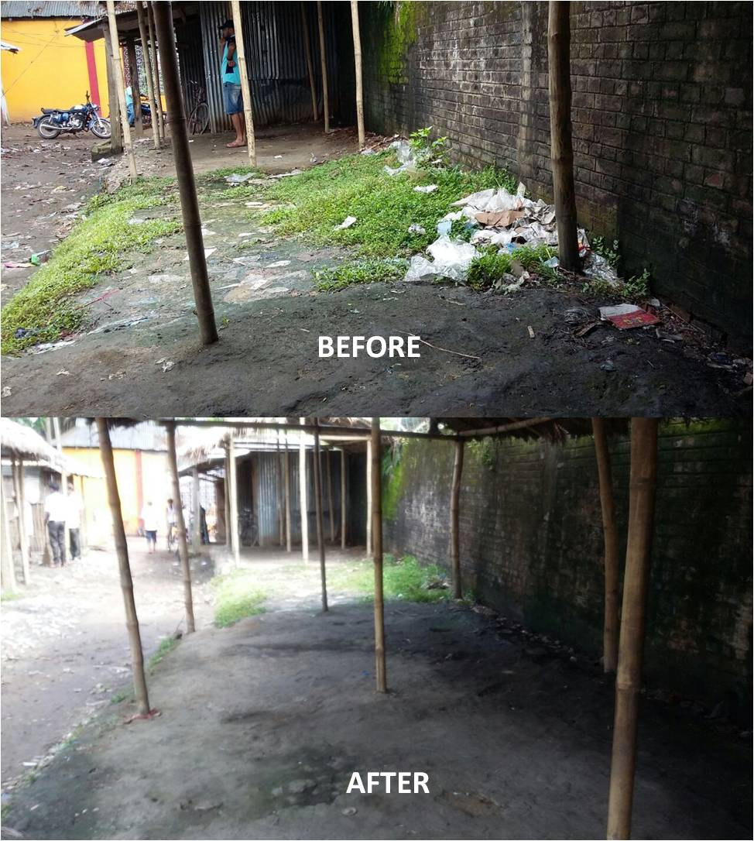 | Cleanliness drive in area near to office or units/ markets
24/07/2017 | 4 | Cleanliness Drive at SMT_ TRX office & surrounding area | 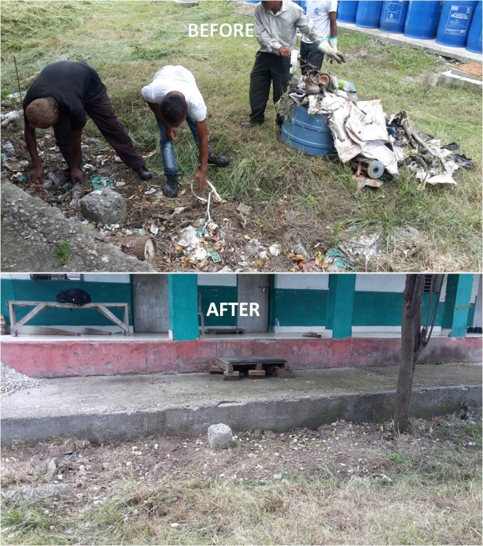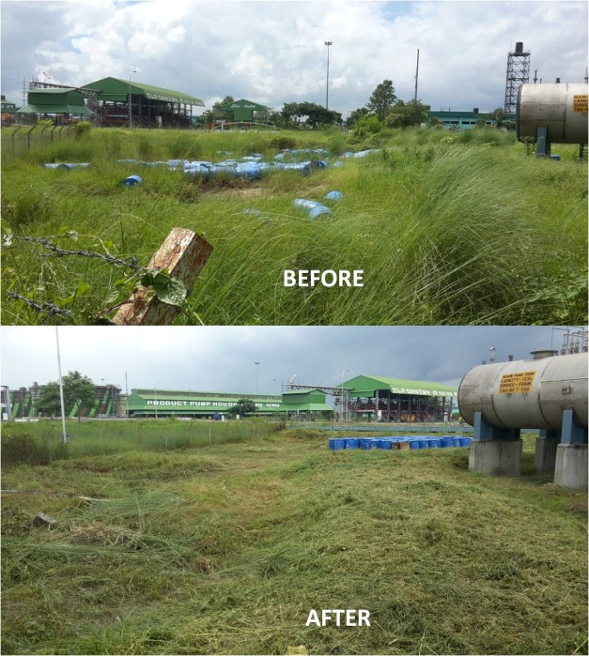 | Cleanliness drive in office/ unit premises

24/07/2017 | 5 | Cleanliness Drive in Township Entrance Gate alongwith distribution of T-Shirts with Swachhata message and Sramdaan by Employee volunteer | 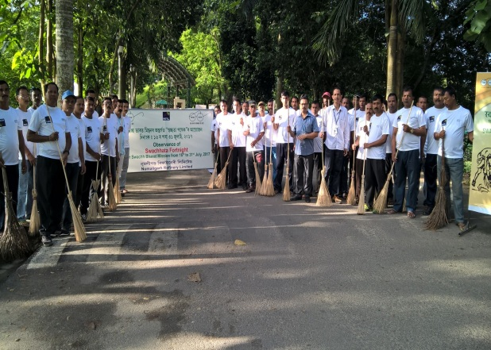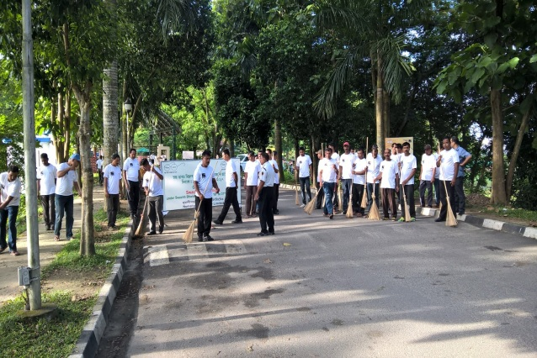  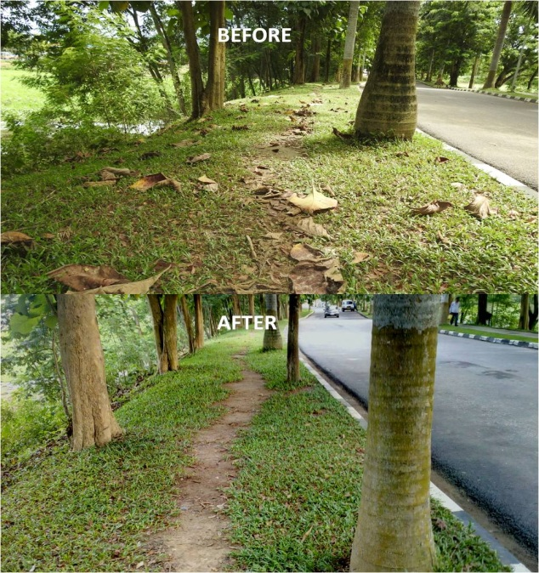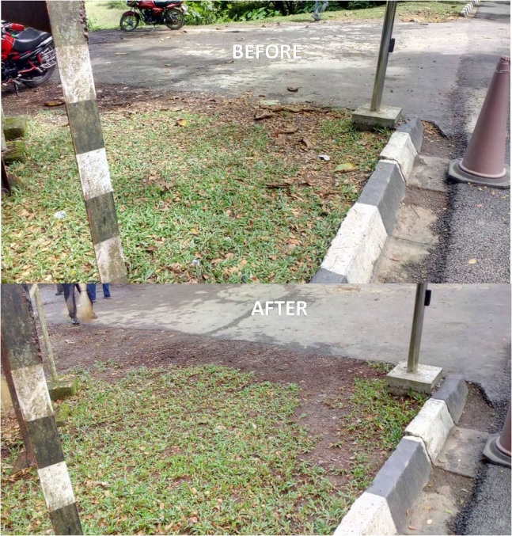 | Cleanliness drives in townships

