ACTIVITIES CARRIED OUT IN NUMALIGARH REFINERY LIMITED ON THE OCCASION OF SWACHH BHARAT PAKHWADA FROM 16TH TO 31stJULY, 2017
Name of CPSE : NUMALIGARH REFINERY LIMITED
Name of administrative Ministry: MOPN&G
Date | Sl No | Activities carried out | Implementation status & photographs | Comments if any
20/07/2017 | 1 | Pledge taking at ETP, NRL | 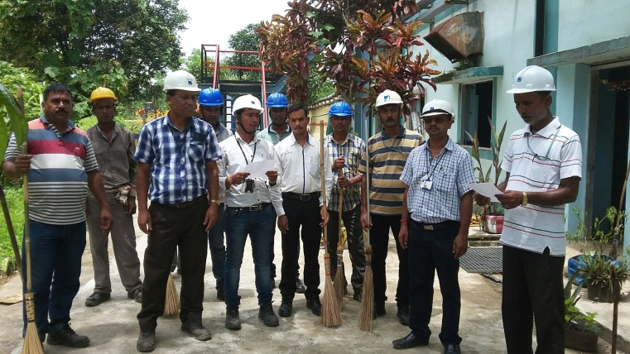 | Pledge Taking

20/07/2017 | 2 | Cleanliness drive in SMT, Siliguri campus | BEFORE AFTER  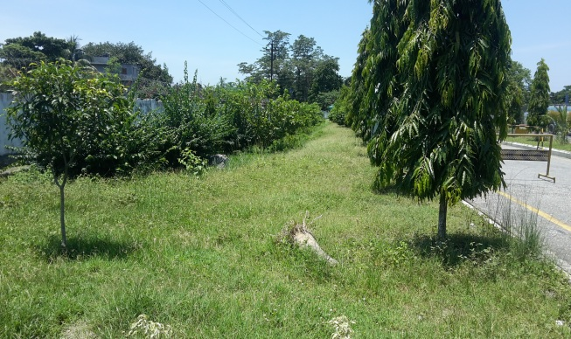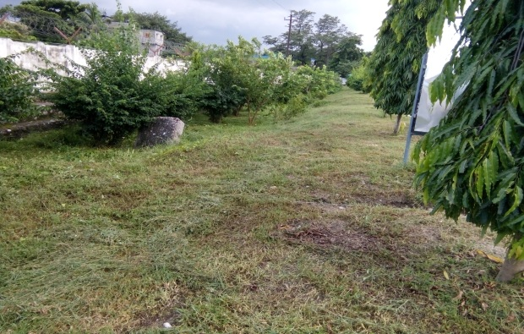 | Cleanliness drive in office/ unit premises
20/07/2017 | 3 | Cleanliness drive at NRL Site (Civil Maintenance Deptt.) | BEFORE AFTER  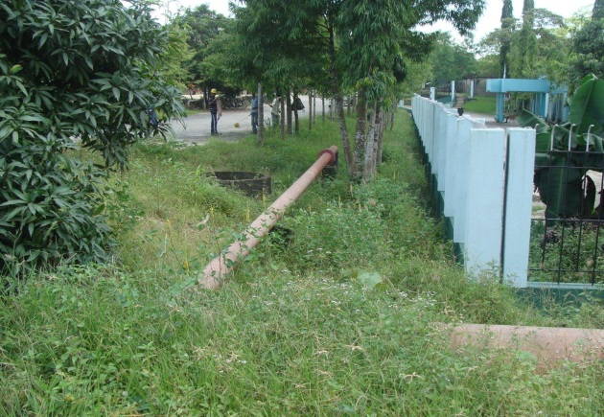  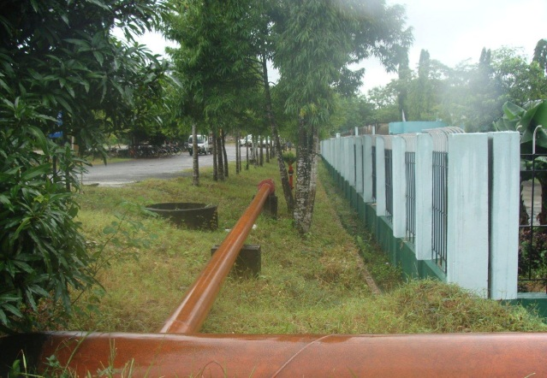 | Cleanliness drive in office/ unit premises
20/07/2017 | 4 | Cleanliness drive in ETP, NRL | BEFORE AFTER  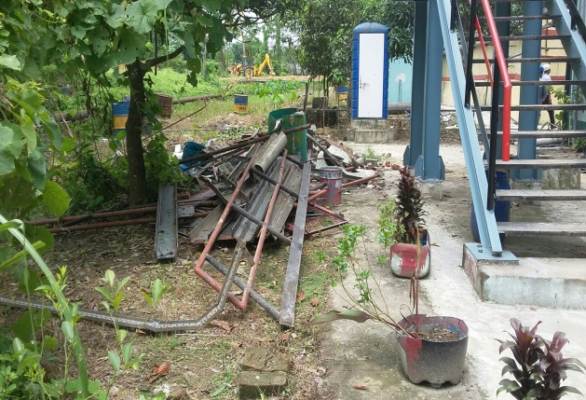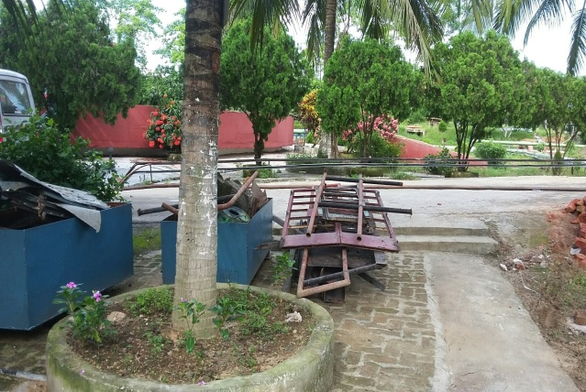 | Cleanliness drive in office/ unit premises

20/07/2017 | 5 | Awareness drive in SMT, Siliguri using audio visual medium for effective awareness. | 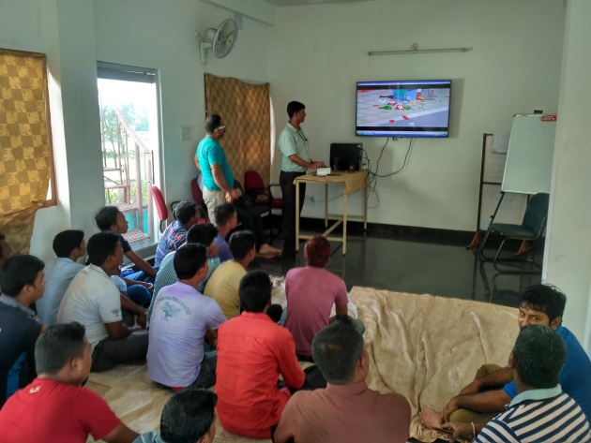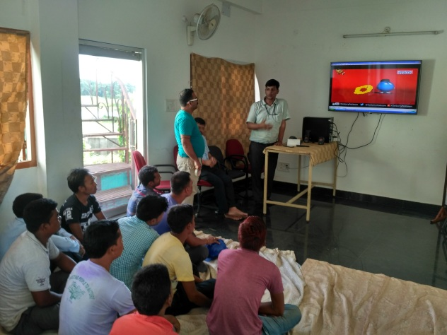 | Awareness Campaign in office

