ACTIVITIES CARRIED OUT IN NUMALIGARH REFINERY LIMITED ON THE OCCASION OF SWACHH BHARAT PAKHWADA FROM 16TH TO 31stJULY, 2017
Name of CPSE : NUMALIGARH REFINERY LIMITED
Name of administrative Ministry: MOPN&G
Date | Sl No | Activities carried out | Implementation status & photographs | Comments if any
19/07/2017 | 1 | Cleanliness Drive at Refinery Complex ( Site Office ) | 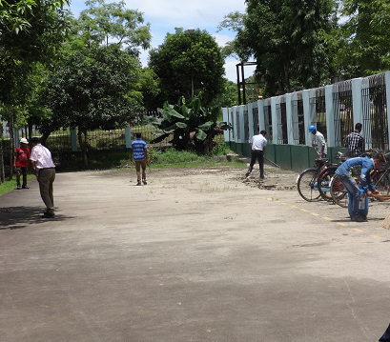  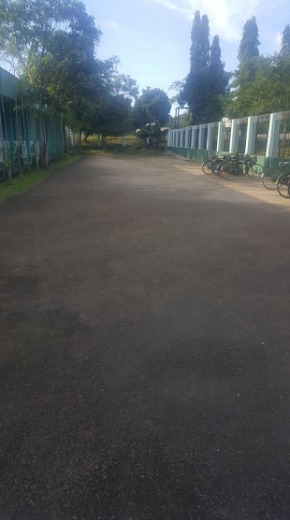  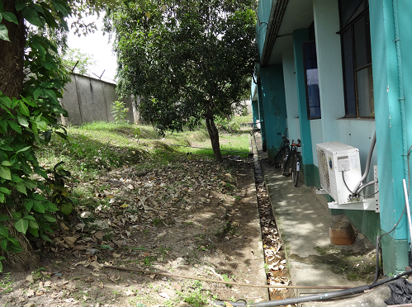  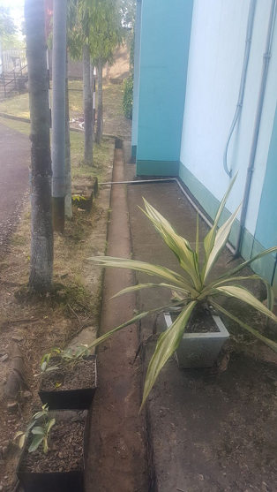  BEFORE AFTER
19/07/2017 | 2 | Cleanliness Drive at Kolkata Coordination Office | 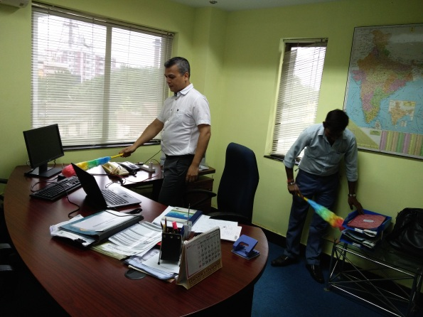  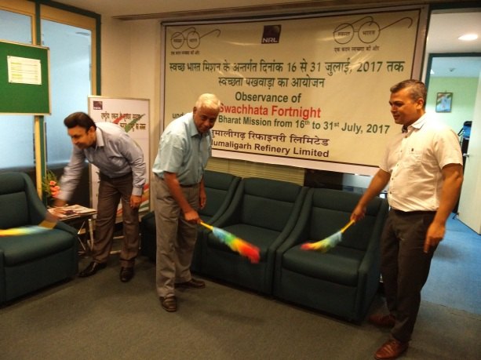  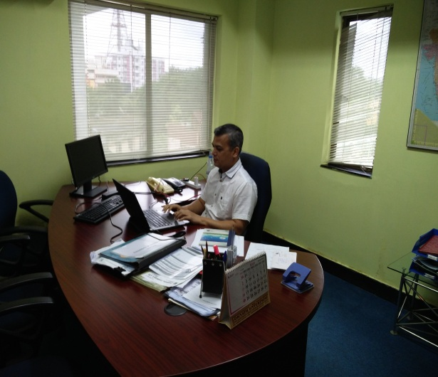  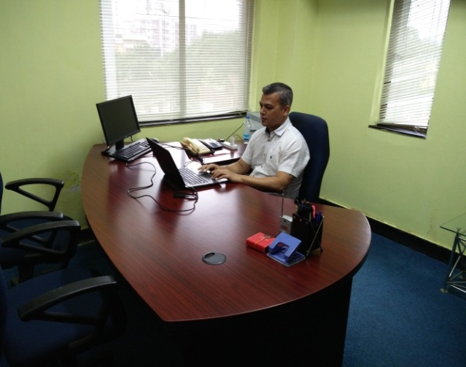  BEFORE AFTER
19/07/2017 | 3 | Awareness & Cleanliness Drive in Pundit Hem Chandra Goswami High School, Doigrung. Along with we also conduct Pledge taking, T-shirt Distribution and also demonstrating Hand washing technique. | 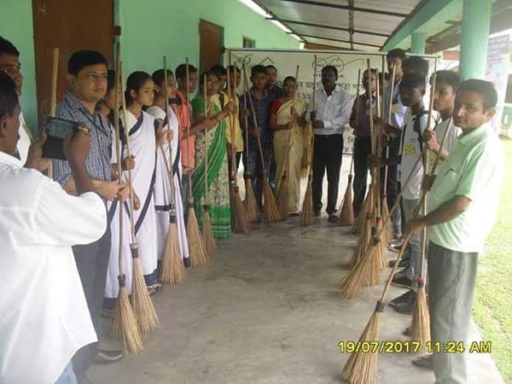  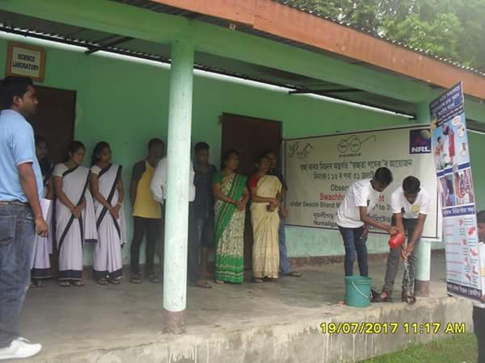  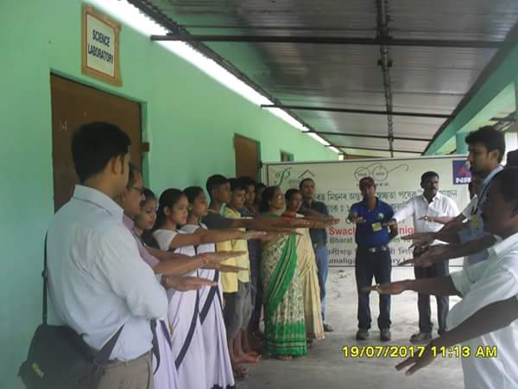  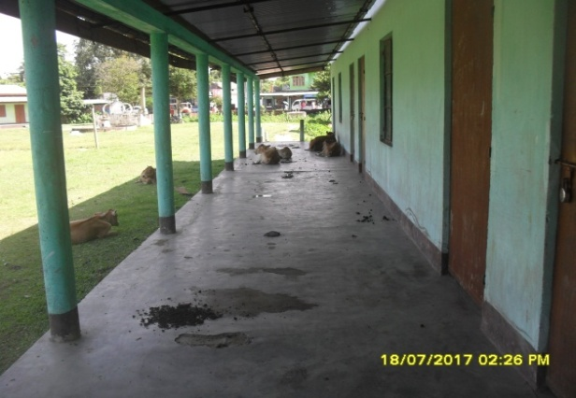  BEFORE AFTER  